# How to change IP addresses in Palo Alto

The purpose of this lab is to design an IP address range and assign them to your inside and dmz network.

Logical drawing:

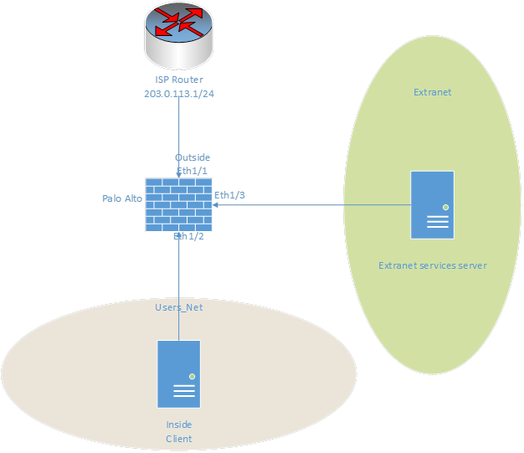

## CONFIGURING IP ADDRESSES

## ACCESSING THE NETWORK INTERFACE ON PALO ALTO

(load snapshot if necessary and commit)

1. Click on network-> interfaces ->eth1/3->IPv4 (different range than eth ½)
2. Enter the addresses, delete the old ones, and click ok after finishing. (Be sure not to commit until all addresses are entered)
3. Click on network-> interfaces -> eth1/2->IPv4, and repeat step 2
4. Click on devices -> interfaces -> management, then enter in a new ipv4 on the same range as your eth 1/2, subnet mask, and gateway(same ADDRESS as your eth ½). Commit the changes

(be sure to enter in the CIDR number with a / after your IP addresses.)

## CHANGING THE VALUES ON YOUR MACHINE

1. Open a terminal, and run the command sudo nano /etc/network/interfaces
2. Using arrow keys, change the settings to the correct values for your network (The gateway = eth ½, network = network ID, IP address = client address (same range as eth ½ and management interface address).
3. Use CTRL+O, enter, and CTRL+X to save and write out of the file.
4. Type in, “sudo reboot”
5. After the reboot, verify that you can connect to the Palo Alto interface by typing “https://<your gateway> into the search bar.
6. If step 5 works, you can proceed to the next step which will be configuring your dmz interface.

## CONFIGURING THE DMZ SERVER

1. Log into the DMZ server with the username : admin and password : Pal0Alt0!
2. Type in the command, “sudo nano /etc/network/interfaces”
3. Do the same thing as step 2, 3, and 4 from the “Changing the values on your machine” section
4. After rebooting the dmz server, switch back to your client

## MAKING A FIREWALL SECURITY POLICY ON PALO ALTO

1. Access your Palo Alto web interface by typing in the gateway that you chose for your inside network
2. Click on “Policies”, “security”, then “add”
3. Name the rule under the “general” tab
4. Change the source zone under the “source” tab to “Users_net”
5. Change the destination zone under the “destination” tab to “extranet”
6. Click OK and be sure to commit your changes.

## TESTING YOUR CONNECTION

1. Open a terminal on your client machine
2. First, try to ping your inside gateway using “ping x.x.x.x”
3. If that is successful, try to ping your dmz gateway
4. Lastly, if that is successful, try to ping your dmz address

## TROUBLESHOOTING/VERIFICATION

1. Double check your values in Palo Alto and make sure they are all in the correct ranges. Make sure your gateways are on the appropriate range.
2. Look over all your values carefully. Make sure they all work with each other and look over all the numbers carefully. A simple typo can make your entire network inoperable.
3. You can verify the networks are able to talk to each other through a simple “ping” command. Remember the rule we created only allows the client to communicate with the DMZ server, not the other way around.

# Firewall configurations and log files

Derek Iszczyszyn

Purpose: To be able to load, save and export firewall configurations through snapshots, examine and create log filters, and use the filter builder.

|  |  |  |  |
| --- | --- | --- | --- |
| VM | IP | Account | Password |
| Client | 192.168.1.20 | Lab-user | Pal0Alt0! |
| DMZ | 192.168.50.10 | Root | Pal0Alt0! |
| Firewall | 192.168.1.254 | admin | Pal0Alt0! |
| Router | 192.168.1.10 | root | Pal0Alt0! |

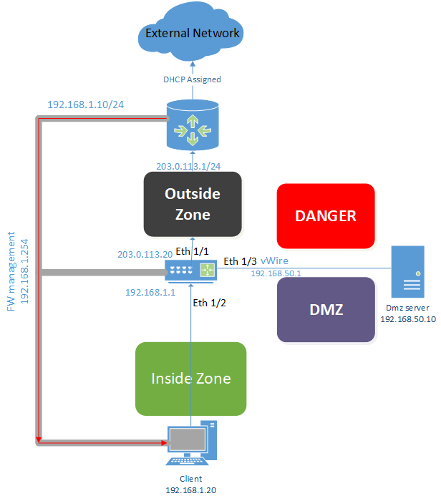

## Saving a named configuration snapshot

You will be saving a firewall configuration with a specific file name

1. Log into the Palo Alto web interface by either entering your gateway or clicking on the bookmark in chromium
2. Once in the interface, select device ->setup->operations. Click on the “Save a named configuration snapshot”.
3. Enter “firewall-a-lab2” in the name of the configuration and click OK, then close

## Exporting a named configuration snapshot

You will be exporting a firewall configuration with a specific file name

1. Go to device->setup->operations. Click “export named configuration snapshot”
2. In the drop down list, select “firewall-a-lab2”
3. On the taskbar of your machine, click the minimize all open windows and show desktop icon.
4. Open the downloads folder on your client, and verify that the export shows up in the folder. Close the download folder.

## Reverting changes in a configuration

The point of this section is very important, as it allows you to revert any changes you may have made to a snapshot by reverting the firewall to the current loaded snapshot configuration. It basically undo’s any changes made and sets you back to the starting point of the configuration.

1. In the web interface, select Device->Setup->Services, then click on the setting icon under the services window in the top right.
2. Change the value for the primary DNS server to 88.8.8.8 and click ok. Verify that the mistake is showing in the services window.
3. In the top right corner of the web interface, select the folder icon(to the right of the lock) and click on revert changes.
4. In the revert changes window, leave the settings default.
5. Click “revert” then close the message window. Notice that the primary dns server has changed back to its original value.

## Previewing configuration changes

Before commit changes to a firewall, you are able to compare the changed configuration to the current running configuration. This can be very useful as it allows you to double check the changes you made before committing any.

1. Modify the SNMP config by going to device->setup->operations, and click SNMP setup under the miscellaneous tab on the lower right side of the screen
2. In the snmp setup window, change the location to Santa Clara, CA, USA. For contact, enter unit 42, and enter paloalto42 in the snmp community string
3. Click on the commit button, click preview changes, and leave the lines of context at 10. Click ok. (do not commit)
4. A new browser named “Device Config Audit” should appear that displays a side by side comparison of the current configuration (left) and the proposed changes in the candidate config(right). Review the settings that were changed.
5. Close the device config audit window
6. Click cancel in the commit window

## Examining log files

In this section you will be examining and navigating through the firewall system log. You can apply the same tasks and technique later on while examining any other log file on the firewall.

1. In the Palo Alto web interface, select Monitor->Logs->System
2. In the System logs window, select the dropdown arrow on the right portion of any column header, and uncheck object to hide the object column.
3. Drag and drop the severity column to the far left position on the screen
4. The table should now display severity as the first column

## Creating a log filter

Create a filter that allows you to browse through logs more efficiently and display logs much quicker that match certain criteria. You will be examining and navigating through the firewall system log.

1. In the Palo Alto web interface, select Monitor->Logs->System
2. In the system log file, delete the filter by clicking the X next to the arrow(above the columns in the searchbar)
3. In the system log file, click any entry under Severity that contains “informational”.
4. The Palo Alto web interface should automatically build a filter statement for you in the search bar. Click the apply filter button(arrow next to the search bar)
5. The system log should update to show entries that contain informational as the severity level
6. Under the Event column, click on anything that contains “general”
7. The interface should update the syntax in the search bar to create a combined filter
8. Click the apply filter button again. The system log should update and display any entries that match both conditions selected by the user.
9. Remove the filter by hitting the “Clear filter” button(The X next to the arrow)

## Using the filter builder

Clicking a link for an entry will automatically create a very simple filter. You can create more advanced filters by clicking multiple links, but there are situations where this will not suffice. For lengthy and advanced searches, you can use the filter builder. You will be learning how to use the filter builder to search the sys log for entries that occurred in the past hour.

1. In the Palo Alto web interface, select the dashboard tab. Under “general information”, scroll to the bottom and find the time. Make note of date and time as it will be needed for a later step.
2. Select monitor->logs->system. Make sure you do not have any filters present in the search bar. Hit the clear filter button if you do.
3. Click the “add filter” button (plus sign next to the X)
4. Under connector, select and
5. Under attribute, select severity
6. Under operator, select equal
7. Under value, select informational
8. Click add ( note the field at the top of the window updates to display correct syntax )
9. While the add log filter window is open, complete the second part of the filter
10. Under connector, select and
11. Under attribute, select time generated
12. Under operator, select greater than or equal to
13. Under value, use first dropdown list to select the date from step 1, and use the second dropdown list to select the time 60 minutes before the time you noticed in step 1.
14. Click add and notice the filter automatically updates in the upper window
15. Click apply, then apply once more through the system log window (arrow next to the search bar)
16. The system log should update and show you entries that match the criteria of the filter you built above
17. Exit the lab! You are complete!

Troubleshooting/verification

1. If your snapshots are not loading when you check the values, double check that you committed the changes.
2. To double check your snapshot got exported correctly, go to your downloads folder on your PC and verify you see the correctly named file.
3. If you run into any issues when attempting to revert the changes, you can always reload the snapshot and try again.
4. To make sure your filters are working, verify that the entries it is showing you match the requirements set in your filter.
5. If your entries are not showing up right away, make sure you applied the filter and refreshed the page if that is not working.
6. ***DOUBLE CHECK YOUR VALUES IF NOTHING IS WORKING!!!***

# Configuring admin users through local databases, LDAP and RADIUS

Derek Iszczyszyn



Purpose: How to setup an Admin user locally, through a LDAP server, and through a radius server.

## Creating a local database Authentication Profile/ user

In this section, you will creating a authentication profile for the local database(allows the firewall to authenticate administrators who need access to , and will create a new entry in the Local User Database under the firewall.

1. Firstly, make sure you load a named configuration for the lab and commit the changes.
2. Head to Device -> Authentication profile. Click the plus sign at the bottom of the window to add.
3. For the name, use “Local-Database”. For the type, use the dropdown list to select Local Database.
4. Select the advanced tab. Under the “Allow List”, click add, select all, and click ok.
5. Go to device -> Local Users Database -> Users. Click the plus sign in the bottom left of the screen
6. For name, type “adminBob”, and for the password enter “Pal0Alt0!” and click OK.

## Creating an Administrator account

You will be creating an administrator account for adminBob. The Local-Database authentication profile will be used with this account.

1. Click device-> Administrators. Click the plus sign in the bottom left of the window.
2. In the administrator window, type in “adminBob” for the name, for authentication profile select “Local-Database”. Click OK.
3. Commit your changes.
4. Logout of the firewall with the “logout” button in the bottom left of the screen next to “admin”.
5. Log back in with the credentials you just made in the previous steps (adminBob and Pal0Alt0!). Close the welcome window. Click remind me later for the telemetry data collection.
6. Navigate to Monitor -> system. Look for an entry that includes Type > auth (may need to scroll through some logs to find one).
7. Log out and log back in with the credentials “admin/Pal0Alt0!”. Click remind me later when prompted with the Telemetry Data Collection window.(This step will not work, you can use the admin account you just made to complete the lab).

## Configuring LDAP authentication

You will be setting up an LDAP server profile that has certain information in it that the firewall will use when sending queries for authentication.

1. On your client desktop, open the folder “Lab files”, “class scripts” then “edu 210”
2. Run the User-ID Data script
3. Minimize the terminal window and reopen the Palo Alto web interface
4. Select devices->Server profiles->LDAP. Click add in the bottom left of the screen.
5. For the name, “LDAP Server Profile”
6. Under server list, click add. Type in “ldap.panw.lab” for the name, 192.168.50.89 for the IP, and 389 for the port.
7. In the Server Settings section, enter dc=panw,dc=lab for the base DN. In the bind DN, enter cn=admin,dc=panw,dc=lab. Enter in Pal0Alt0! For the password
8. Verify the newly created LDAP config shows up in the list.
9. Go to authentication profiles under device, and click add
10. Name the new profile “LDAP Auth Profile”. Select LDAP for the type, and LDAP server profile under server profile. Under the advanced tab, select add then click on “all”
11. Go to administrators under devices, and click on add. For the name, “adminSally”, for the Auth profile, select LDAP Auth profile. Click ok and commit your changes.
12. Logout and back in with the new credentials “adminSally” and “Pal0Alt0!”. Click close, then remind me later. Verify the logs show up under Monitor-> system. You are looking for a Type > auth log.
13. Log out then back in with the credentials “admin” and “Pal0Alt0!”

## Configuring RADIUS authentication

You will be configuring radius authentication and testing to see if it worked.

1. First, head to device->Server Profiles->Radius->Add
2. Enter RADIUS Server Profile in the name, CHAP for Auth protocol. Click add under servers, enter radius.panw.lab for the name, 192.168.50.150 for the RADIUS server, Pal0Alt0! For secret, and port 1812 for the port number. Click OK when done.
3. Head to authentication profiles next under “device”. Click add. Enter “RADIUS Auth Profile” for the name, RADIUS for the type, and RADIUS Server Profile for the server profile. Under the advanced tab, click add, then all, then ok.
4. Head to administrators, click add, adminHelga for the name, then RADIUS Auth Profile for the Auth profile. Click OK then commit your changes.
5. Logout and try to log back in with “adminHelga” and “Pal0Alt0!”.
6. Check your monitor->system for another Type > Auth log confirming adminHelga signed in.
7. After verifying the log showed up, log out and log back in with “admin” and “Pal0Alt0!”

## Configuring an Authentication sequence

You will be configuring an authentication sequence. This will instruct the firewall to check LDAP first, and then radius for authentication. This is necessary if you have users from both LDAP and radius so that it can check both external databases when an admin user attempts to log in.

1. Head to device->Authentication Sequence. Click add. For the name, enter LDAP then RADIUS. Under Auth profiles, add LDAP, and then add RADIUS profiles. Click OK then commit your changes. The lab is now complete!

## Troubleshooting/Verification.

1. The first major problem I ran into when starting this lab was not loading the correct snapshot. When I tried to make the account “adminSally”, it would not let me in as radius was not set up in the snapshot I had previously selected. VERY IMPORTANT TO SELECT THE CORRECT SNAPSHOT!
2. Double check to make sure you set the server profiles and authentication profiles to match up with the respective admin that you are trying to use with that server. (Make sure LDAP server profile and AUTH profile are being used, same with RADIUS when trying to connect to appropriate servers.)

# Connecting the Firewall to Production Networks

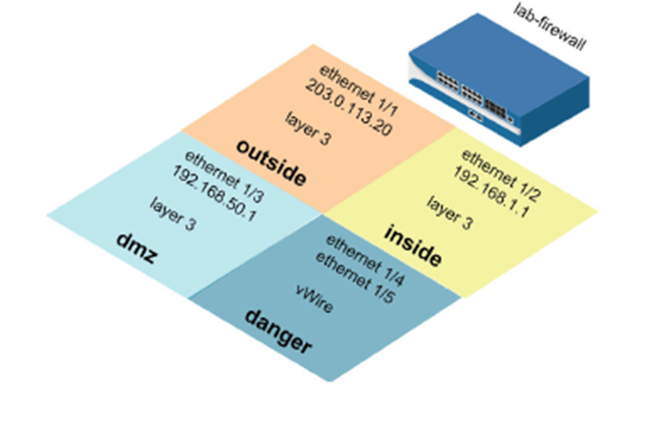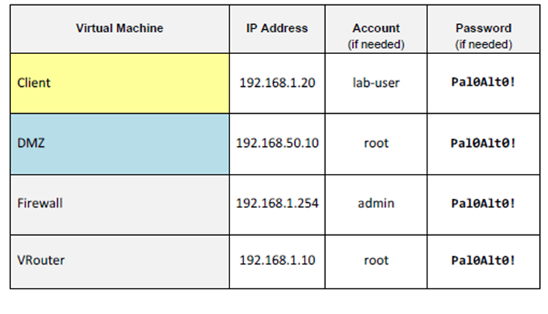

## Loading a snapshot config

You will be loading a configured snapshot to start the lab like usual

1. Navigate to the Palo Alto web interface and login with credentials “admin” and “Pal0Alt0!”
2. Head to Device->Setup->Operations and load a snapshot of the necessary lab (lab 4 snapshot for this case). Click OK and commit your changes

## Creating a layer 3 network interface

You will be creating a layer 3 interface on your network that provides basic network connectivity to your production network.

1. In the web page interface, select Network->interfaces->ethernet. Click on ethernet 1/1. Enter in “Internet connection” for comment, Layer3 for interface type, and none for virtual router.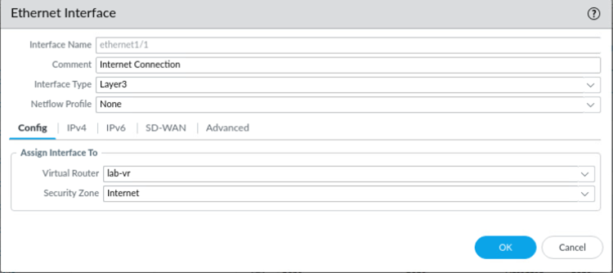
2. Select the IPv4 tab. Click add and enter in 203.0.113.20/24 and click OK. This is your ISP address.
3. Click ethernet ½. Add “Users network connection” for a comment, Layer3 for interface type, and none for virtual routers. Select the IPv4 tab once again, and add the address 192.168.1.1/24. Click OK.
4. Click ethernet 1/3. For the comment, type in Extranet servers connection. For the interface type, layer 3 once again, and none for virtual router. Select the IPv4 tab and add the address 192.168.50.1/24 and click OK.
5. Confirm that the eth 1/1, ½, and 1/3 all show up with the correct addresses entered in the ethernet table.

## Creating a virtual router

You will be creating a virtual router for your layer 3 interfaces to connect to. The firewall requires a virtual router in order to obtain routes from other subnets.

1. Select network->virtual routers
2. Click on default to open the default router
3. In the virtual router window, rename the default router to “lab-vr”. Click add and select eth 1/1, ½, and 1/3.
4. Click on static routes on the side of the virtual router window. Under the IPv4 tab, click add. For name, “Firewall Default Gateway”. Add 0.0.0.0/0 under the destination, eth 1/1 for interface, and 203.0.113.1 (ISP ADDRESS!) under the IP address for next hop. Click OK twice.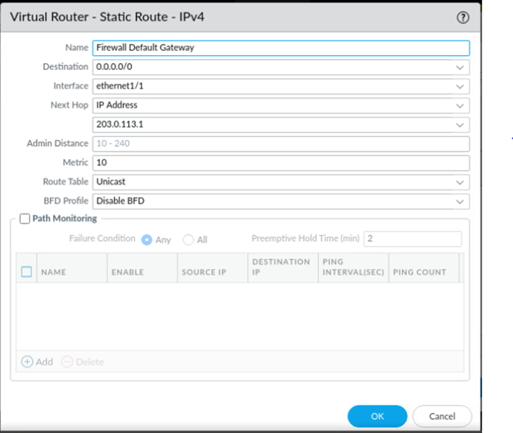

## Segment your production network using zones

Security zones are a way to group physical and virtual interfaces on a firewall to control and log traffic that travels across your network.

1. Select network->zones
2. Click add. Enter internet for name, Layer3 for type. Under interfaces, click add and select eth 1/1. Click OK.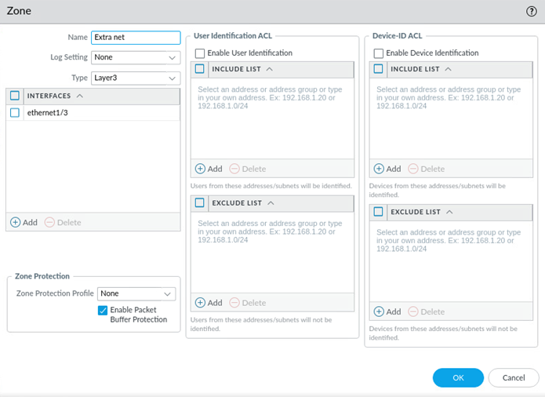
3. Click add to create another zone. For name, Users Net. For type, Layer3. Select eth ½ for the interface.
4. Click add for the last interface. For name, Extranet. Type: Layer3 once again. Under interfaces, add eth 1/3.
5. Commit your changes and click ok once finished.

## Testing connectivity to each zone

1. Minimize the Palo Alto web interface. On your client’s desktop, open the Remmina application. Double click on “Firewall-A”. Click OK when the warning window pops up.
2. At the command line, enter in “ping source 192.168.1.1 host 192.168.1.20” Allow the command to run for a few seconds then hit CTRL+C.
3. Enter “ping source 192.168.50.1 host 192.168.50.150” Allow the command to run once again before cancelling.
4. Enter “ping source 203.0.113.20 host 8.8.8.8”. CTRL+C after a few seconds.
5. Close the Firewall-A terminal, then close the remmina terminal.

## Testing interface access before management profiles.

Management interface profiles allow you to enable certain network services on specific firewall interfaces.

1. Open the terminal emulator on your client’s desktop.
2. Enter “ping 192.168.1.1” and hit enter. CTRL+C after a few seconds as it will not succeed.
3. Enter “ssh [admin@192.168.1.1](mailto:admin@192.168.1.1)” and hit enter. CTRL+C after a few seconds as it will fail.
4. Leave the terminal open and reopen your Palo Alto web interface.

## Define interface management profiles.

You will define two interface profiles. One profile will allow ping, the other will allow ping and secure management traffic, including SSH and HTTPS.

1. Select network->network profiles->interface mgmt. Click add.
2. Enter allow-ping for the name. Check the box for ping. Click OK.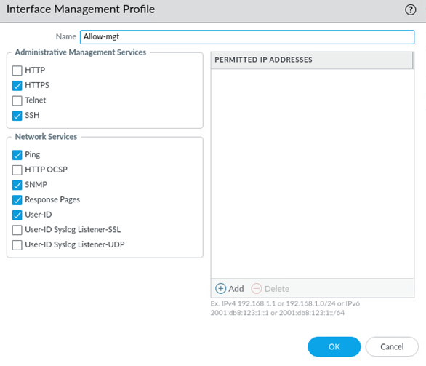
3. Click add once again. Enter “allow-mgt” for the name. Check HTTPS, SSH, PING, SNMP, Response pages, and User-ID. Click OK.
4. Select network->interfaces->ethernet. Click eth 1/1.
5. Under the advanced tab, select “allow-ping” for the management profile. Click OK.

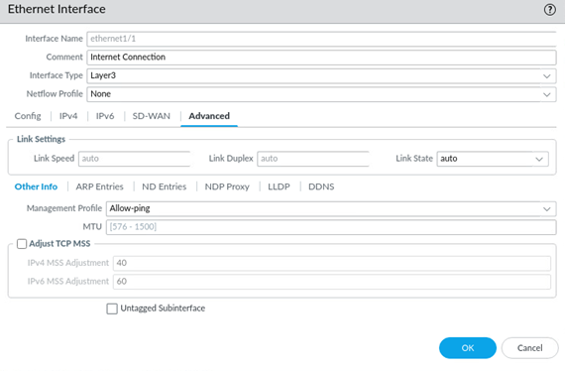

1. Click eth ½. Under advanced, select allow-mgt for the management profile. Read the warning and click yes.
2. Click eth 1/3. Under advanced, select allow-mgt for the management profile. Read the warning and click yes once again.
3. Double check to make sure your table is providing the correct information that you entered earlier.
4. Commit your changes.

## Testing interface access after management profiles

You will be using the ping command to test connectivity, and ssh to attempt to connect to the ssh service to prove that it was successful

1. Open the terminal emulator on your client’s desktop.
2. Type in “ping 192.168.1.1” and hit enter at the command line. Wait a few seconds before using CTRL+C to stop the command.
3. Elevate to sudo user by typing in “sudo su” then hit enter.
4. Type in “ssh [admin@192.168.1.1](mailto:admin@192.168.1.1)” then hit enter. Type in yes and hit enter when prompted. Type in Pal0Alt0! For the password. The firewall should now present the SSH CLI interface.

## Troubleshooting/Verification

1. Try to ping all of your addresses in the correct program. Some pings may not work if you try them in the terminal emulator for example.
2. Make sure you correctly entered all of your values and assigned the correct zones.
3. Be sure that you have the correct snapshot loaded

Configuring NAT PAT and security policies

Derek Iszczyszyn

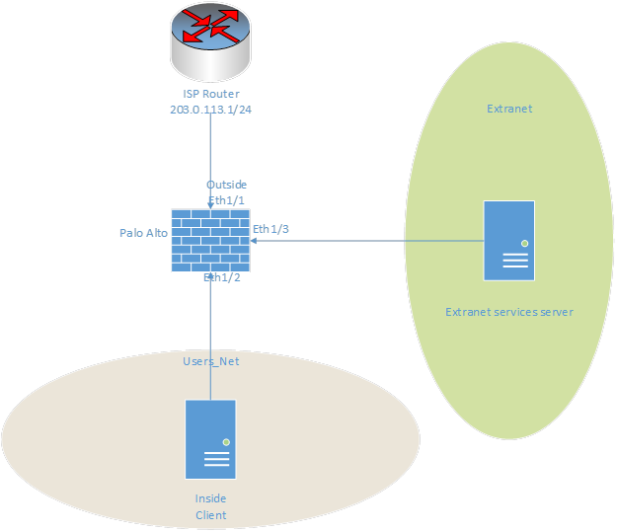

|  |  |
| --- | --- |
| Device Name Interface | Address |
| Inside Client à Located in the Users_Net | 192.168.6.34 /28 |
| Palo Alto Ethernet ½ Users_Net | 192.168.6.33 /28 |
| Palo Alto Management Virtual Interface  (Remember that this address is in the same host range as the Inside Eth1/2 and the Inside client) | 192.168.6.46 /28 |
| Palo Alto Ethernet 1/1 outside | 203.0.113.20 /24 |
| Palo Alto Ethernet 1/3 ExtraNet | 192.168.50.1 |
| Extranet Server * | 192.168.50.10 |

## Configuring IP addresses

In this step you will be changing the IP addresses on your Palo Alto web interface and on the terminal of your client’s device.

1. Load the appropriate config snapshot for the lab
2. Refer to your documentation on changing the IP addresses in Palo Alto and on your client device from the previous labs.
3. Commit your changes
4. Change the values on your client device’s terminal and sudo reboot
5. Log into the Palo Alto web interface using your new gateway

## Configuring NAT/PAT policies

In this section you will be setting up the NAT and PAT services and setting up basic security policies that allow communication between devices on the network.

1. Navigate to Network->Zones. (Notice that Extranet is associate with 1/3(DMZ interface), Users_Net is with eth1/2(inside network), and Internet is eth1/1 which is our interface that connects to our ISP).
2. Verify the presence of a default route on our virtual router that heads to our ISP by going to Network->Virtual Routers->VR-1->Statis routes. Notice the configuration.
3. Select Policies->NAT->add and give the policy a self-describing name.
4. Configure the settings on the original packet tab. Select Users_net for source zone, and internet as the destination zone.
5. For the translate packet, enter the values as shown. Click OK.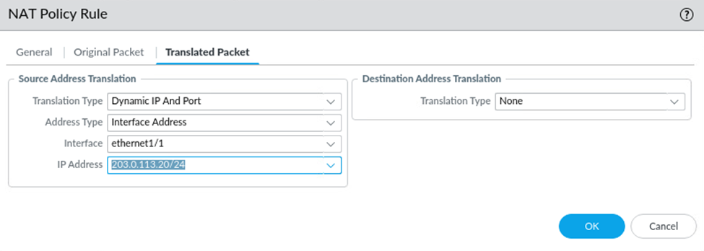

## Configuring Security Policies for Internet Traffic

1. Head to Policies->Security->add and give it a descriptive name.
2. On source, add users_net security zone.
3. On destination, add the Internet zone.
4. Check that Any is checked in the application tab.
5. Set the service/url category to application-default if not already selected.
6. Set the actions tab to ‘allow’
7. Click OK and commit your changes. Test it by attempting to browse to an internet website.

## Configuring Security Policies for Destination NAT

1. Head to policies->NAT->Add and give it a name ‘DMZ-Access’
2. On the original packet tab, select Internet for source zone, Internet for destination zone, and add a new ISP address ‘203.0.113.21’
3. Enter in the values for the translated packet tab as shown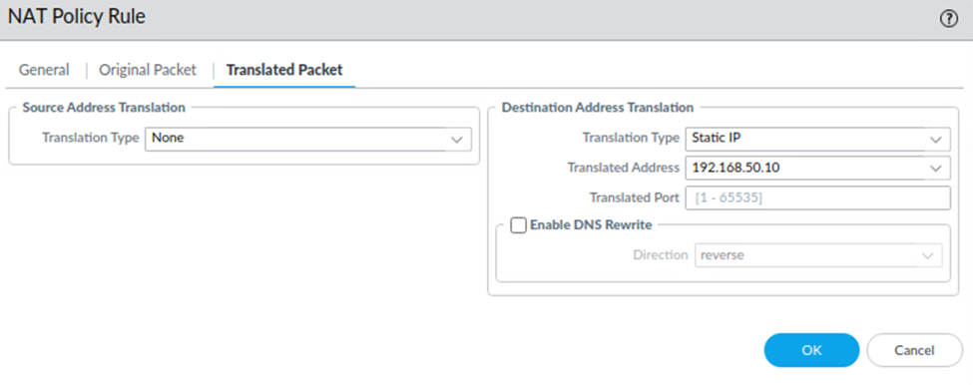

*notice the translated address Is the actual address of our DMZ server*

1. Create a security policy for DMZ access by navigating to policies->Security-> add. Give the new rule a name like ‘DMZ-Access-Policy’
2. Under Source tab, select internet for the source zone.
3. Under Destination tab, select Extranet for the destination zone.
4. Add the permitted applications of ping and ftp under the application tab.
5. Leave the ‘application-default’ under the application tab.
6. Leave the default action of allow under the actions tab. Click OK and commit your changes.
7. Test your destination NAT and associated security policy by clicking on the vrouter tab at the top of your netlab client. Try to ping our ISP (203.0.113.21) from the vRouter. (root, Pal0Alt0! For credentials).\
8. Try to ping your dmz server(192.168.50.10). It should fail.
9. Test that you can load FTP from your vRouter. To do this you need to install an FTP client on the Linux vRouter client. Run ‘sudo yum -y install lftp’. After it is installed, type ‘lftp 203.0.113.21 -u lab-user,Pal0Alt0! Once you are in, type dir to see the contents of the typ server. Try doing the same thing but with the 192.168.50.10 address. It will fail for the same reason the ping command did. Remove the allowed ping application from the security policy and attempt to ping the ISP address. It should not work but you should still be able to connect to lftp using the ISP.

## Troubleshooting/Verification

1. Verify that you are able to connect to a website through your client’s device. If you are unable to, go back and check your work.
2. Attempt to ping your ISP through your vRouter. If that is not working, go back and double check your values entered. It is important to make sure you have the correct addresses plugged into your Palo Alto web interface.
3. If your commit is not going through, make sure you changed your values on your actual client device through the terminal. *MAKE SURE your gateways for eth ½ are entered in your Palo Alto management interface and you have the correct IP addresses, ranges and values entered. Check subnet

Palo Alto Clean Install

Derek Iszczyszyn



|  |  |
| --- | --- |
| Device Name Interface | Address |
| Inside Client | 192.168.1.20 /24 |
| Palo Alto Ethernet 1/2 inside | 192.168.1.1 /24 |
| Palo Alto Ethernet 1/1 outside | 203.0.113.20 /24 |

# Resetting factory default settings

This will reset the device to its factory default settings to better simulate a clean installation

*be sure to use the first lab when scheduling a netlab pod!!!*

1. Click on the ‘firewall’ tab in netlab.
2. Login with ‘admin’ and ‘Pal0Alt0!’
3. Type ‘debug system maintenance-mode’. Answer yes/y to reboot. *this will take a bit*
4. Hit enter once the device boots. Select ‘Factory Reset’ from the menu and press enter.
5. Select ‘Factory Reset’ again for the second time and hit enter.
6. Choose ‘Reboot’ from the menu and hit enter. Login with default username/password (admin/admin). *remember to wait about five minutes for all the services to load**correct prompt you should receive eventually is to change password*
7. Enter ‘admin’ for the prompt ‘Enter old password’
8. Change the new password to ‘Pal0Alt0!’ *after this step, your device settings and config should be default*
9. You should now be in PANOS Operational mode.

# Creating an RSA certificate for encryption (https, ssh, etc).

1. Type in ‘request certificate generate ca yes certificate-name PACert name paloalto.class algorithm RSA rsa-nbits 2048 *remember you can use tab auto-completion when entering these commands in*
   1. PACert is user-defined name for the cert, paloalto.class is user-defined and would be your domain name.
2. Enter configuration mode with the command ‘Configure’.
3. Assign the certificate to ssl service (https) which will be used for management
   1. Type in ‘set shared ssl-tls-service-profile PA_PROFILE certificate PACert protocol-settings min-version tls1-0 max-version tls1-2
   2. PA_PROFILE is user-defined profile name for the cert profile. Notice PACert is used again here, which is the cert name made by the user.
4. Set the certificate profile ‘active’
   1. Type in ‘set deviceconfig system ssl-tls-service-profile PA_PROFILE
   2. Notice the user-defined profile name at the end of the command.
5. Configure an IP address on eth ½ (inside interface)
   1. Type ‘set network interface ethernet ethernet1/2 layer3 ip 192.168.1.1/24
6. Create a virtual router then assign eth1/2 as an interface on the VR
   1. Type ‘set network virtual-router vm-lab interface ethernet1/2
   2. vm-lab is user defined name for the VR
7. Configure the inside security zone then assign the interface above to the inside zone
   1. Type ‘set zone inside network layer3 ethernet1/2’
8. Set the allowed management network to define which devices can manage firewall
   1. Type ‘set deviceconfig system permitted-ip 192.168.1.0/24’
9. Create interface profile, defining permitted traffic for managing the device on the interface/ allowed devices and network
   1. Type ‘Set network profiles interface-management-profile <name> https yes ping yes permitted-ip 192.168.1.0/24’
   2. Chose whatever interface mgmt profile name you want for <name>*use mgmt*.
10. Assign the created interface profile to your inside interface
    1. Type ‘Set network interface ethernet ethernet1/2 layer3 interface-management-profile <name> *use whatever name you decided for last step*
11. Type ‘commit’ and hit enter to save and implement your changes.
12. Enter operational mode once again by typing ‘exit’
13. Verify your changed by typing the following.
    1. show interface ethernet1/2
    2. show routing route
    3. Ping source 192.168.1.1 count 3 host 192.168.1.20
    4. From the terminal on your inside client, ping 192.168.1.1. Hit CTRL+C.
    5. From the firewall, type ‘show arp ethernet1/2’
14. From your inside client open the firefox browser to ‘https://192.168.1.1’
15. Skip past the certificate error by clicking on ‘advanced’ then select ‘Accept the risk’. Log into the web interface using admin/Pal0Alt0!. Select ‘Remind me later’ when asked about telemetry.
16. Navigate to Device>Interfaces>Management
17. Fill out the form as shown below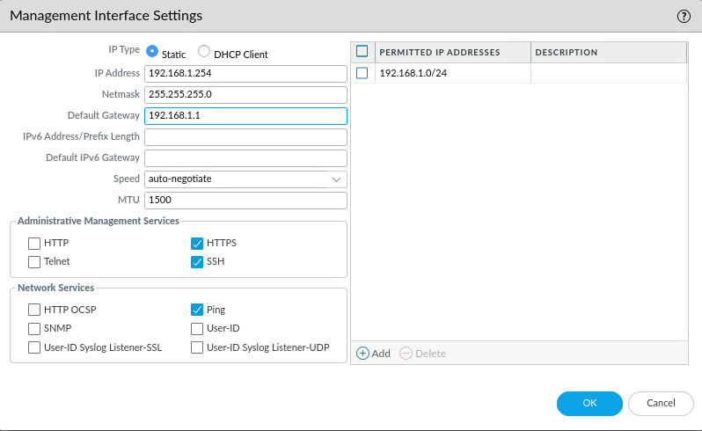
18. Click ok then commit your changes at the top right.
19. Close your web browser and open a new session with the new mgmt address, https://192.168.1.254. Login with appropriate credentials.

# Securing the inside interface

1. Now you will secure the inside interface by modifying the Interface mgmt profile assigned to the eth1/2 interface that was originally assigned in the CLI portion of this lab that allowed you to connect to the device to manage it.
   1. Go to network>network profiles>interface mgmt.
   2. Click on the interface mgmt. profile you created earlier and unselect https. Notice ping is still selected. Commit your changes.
   3. Try connecting to <https://192.168.1.1> (eth ½) It should fail.
   4. Try pinging the address. It should work.
   5. Doing this forces the firewall manager to use the new mgmt. interface for access to the device.
2. Reconnect using the mgmt. address (192.168.1.254).
3. Add your outsize zone. Network>Zones>Add. Give it the name ‘outside’ and choose layer3 as the type. Click OK.
4. In order to assign eth1/1 to the outside interface and add it to the VR, select ‘network>interfaces>ethernet>ethernet1/1. Select Layer 3 as the interface type, vm-lab as the VR, and outside as the security zone.
5. Select the IPv4 tab, click add>new address and you should see a form to create an address object, with the name Outside Interface (address of 203.0.113.20/24)*ISP* which will be assigned to this interface. Click OK once you added the outside interface to the IPv4 addresses.

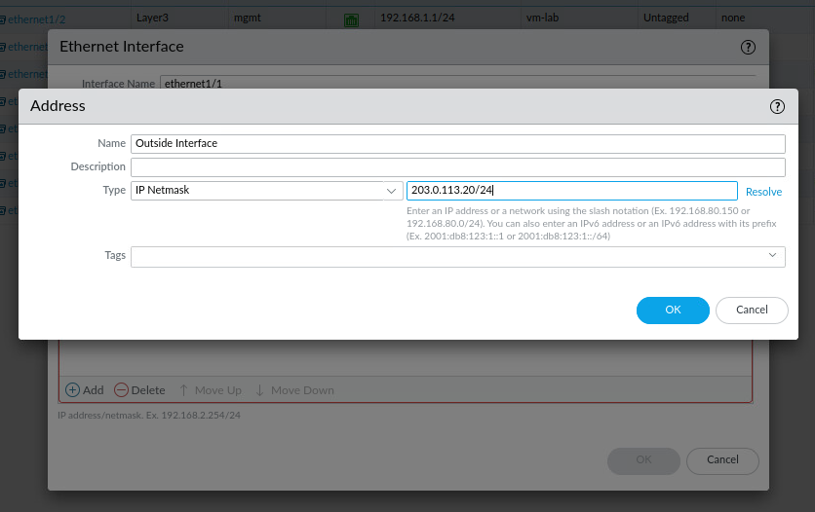

1. Setup your static route to the ISP gateway.
   1. Head to network>virtual routers>vm-lab (note that we created this in the CLI)
   2. Click on static routes
   3. Click add and configure as shown below

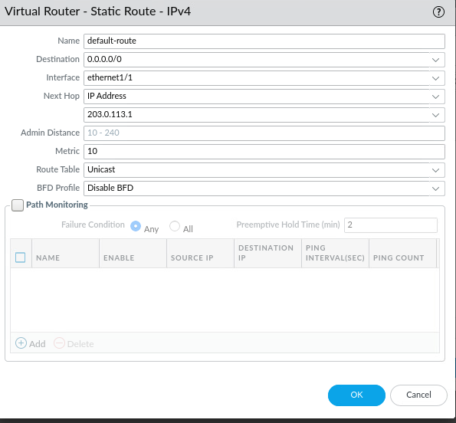

1. Click ‘OK’ and close out of the virtual router window.

# Setting up NAT/PAT

This needs to be done in order to access the internet

1. Navigate to policies>NAT>Add. Configure as below.

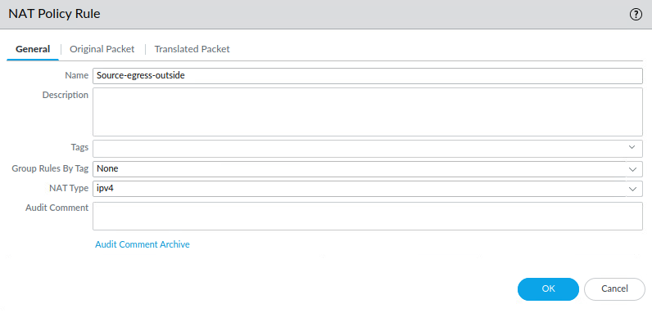

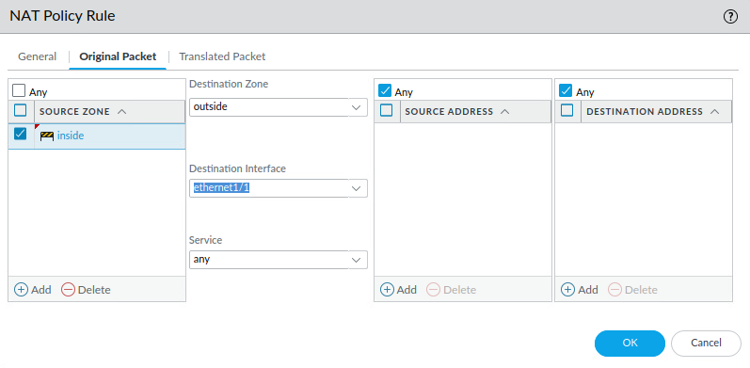

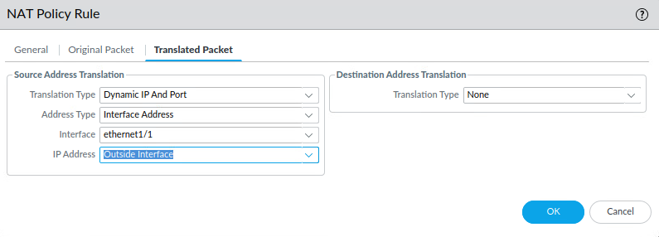

1. Click OK

# Creating a security policy for cross-zone traffic

This will allow traffic to flow between the created zones.

1. Click policies>security>add. Configure according to the screenshots below.

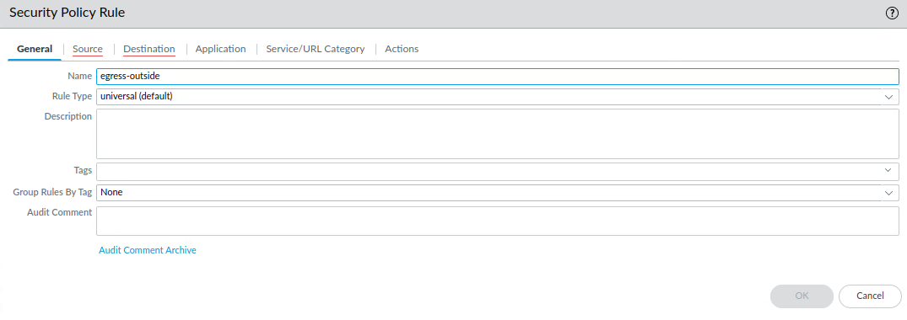

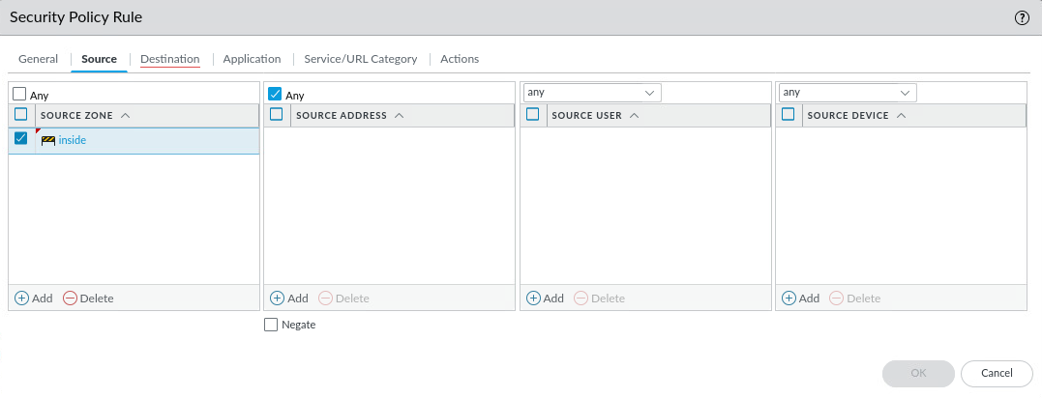

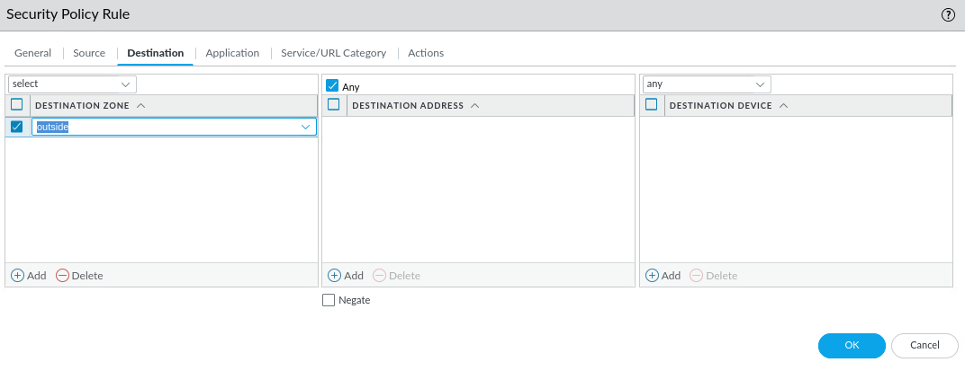

1. Click OK and commit your changes. Test that you can browse to a website on the internet.
2. Create address objects for the DMZ server’s public/private addresses to better implement them in the settings below.
   1. Click objects>addresses>add. Configure the object for the private DMZ server addresses with the name ‘DMZ-Server-Private’ and an address of ‘192.168.50.10’. Click OK. Add another address object for the public address of the DMZ server with the name ‘DMZ-Server-Public’ and the address of ‘203.0.113.21’
3. Create a dmz zone as you did with the outside zone earlier. Assign interface eth 1/3 to the DMZ (done through network>interfaces>ethernet 1/3. Make sure you select layer3 as the type otherwise you will not be able to supply an IPV4 address, then going back to the zone tab and adding it as interface), add it to the VR, and give it an address of 192.168.50.1/24
4. Next, setup your DMZ by creating a static NAT entry. Create a new NAT policy with the name ‘Static-DMZ’ for your DMZ server as shown below.

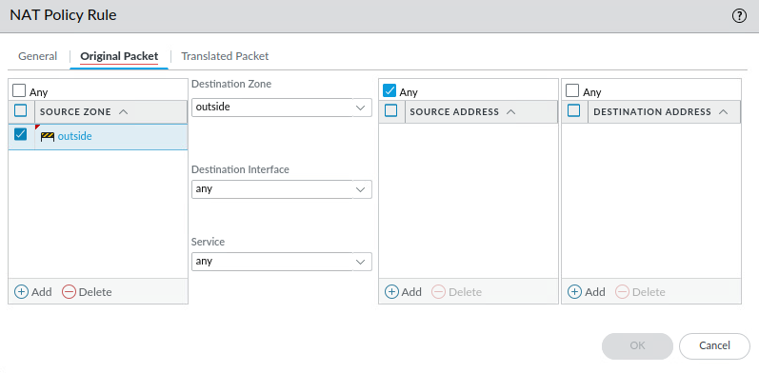

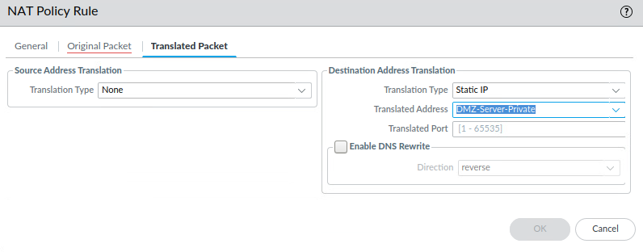

1. Create a security policy for traffic moving from outside > dmz by making a new security policy. For name, DMZ-Access. For source zone, outside, then any for source address. Destination zone = DMZ, dest address = DMZ-server-public. For application, select ftp, ping and web-browsing. Select Any for service/URL category instead of application-default and leave actions default.
2. After selecting OK make sure you commit the changes.
3. Test that you can ping the DMZ server from the vRouter (203.0.113.21). Login with root/Pal0Alt0!.
4. Test that you can load FTP from the DMZ. Run ‘sudo yum -y install lftp’. Once installed, type ‘lftp 203.0.113.21 -u lab-user,Pal0Alt0!. Once in, type dir to see the contents of the ftp server.
5. Next, install license to use all features, including traffic logs. You will not be able to see any logs before you do this.
6. Set up a preferred DNS server (8.8.8.8) by heading to Device>Setup>Services. Chose the settings gear in the upper right corner, and enter in ‘8.8.8.8’ for primary DNS server. Select OK then commit.
7. Install the license feature by heading to Device>Licenses>Activate feature using authorization code. Enter the code I4440990 *capital i at the beginning*
8. Now that you have a working configuration, you will save it in order to retrieve it for future labs. Chose device>Operations>Save named config snapshot. Give your saved snapshot a name. Export your saved snapshot and chose the name you gave above. Upload the downloaded file *MAKE SURE IT HAS .xml extension!!!* to one drive or google drive. *VERY IMPORTANT STEP*
9. Test that you can load your saved snapshot by creating a new reservation, downloading the file from onedrive and loading it like you would with any other snapshot. Hit commit, and test that you can ping your DMZ from the vRouter. If you can do this you succeeded. *You may have to import your saved config before you can load it.*

# Verification/Troubleshooting

1. Test your web browsing capabilities for your NAT policies. If it does not work something was entered wrong/ setup incorrectly when configuring your NAT policies / security policies.
2. If you do not see your saved snapshot config in the ‘load’ list, you will need to import it as a snapshot after you download it. It will also not work if there is no XML extension on the file.
3. If you run into early issues with your CLI commands, it is likely that you need to do the reboot step again. I missed doing this my first time and when it was time to set the ethernet interface, it was outputting an error at me that eth1/2 was already in use.
4. Try to ping the DMZ from vRouter to confirm connection is working between the two servers.
5. Try to ping the management address from your client

Denial of Service protection/URL Filtering

Derek Iszczyszyn

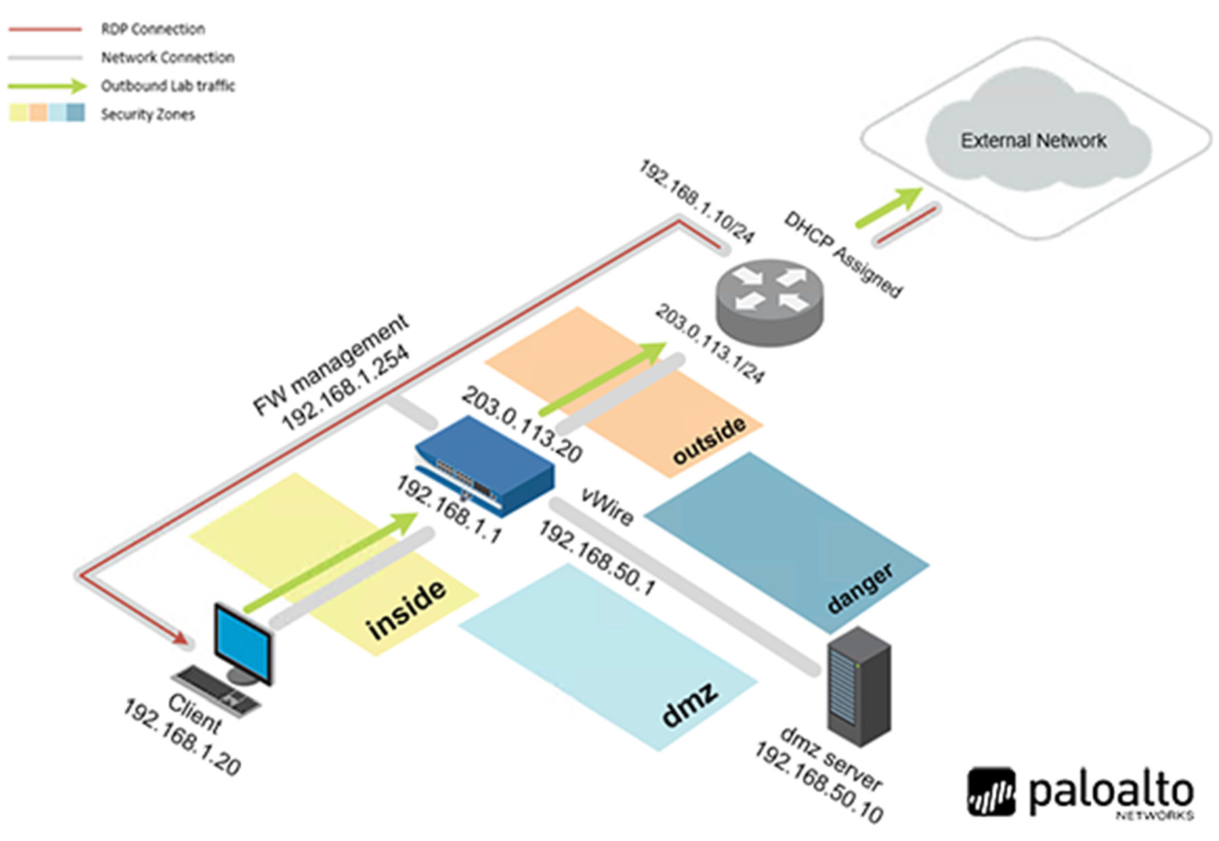

|  |  |  |  |
| --- | --- | --- | --- |
| **Virtual** **Machine** | **IP** **Address** | **Account**  (if needed) | **Password**  (if needed) |
| Client | 192.168.1.20 | lab-user | **Pal0Alt0!** |
| DMZ | 192.168.50.10 | root | **Pal0Alt0!** |
| Firewall | 192.168.1.254 | admin | **Pal0Alt0!** |
| VRouter | 192.168.1.10 | root | **Pal0Alt0!** |

## Generating SYN Flood traffic

You will be running a script on the client host machine under the users_net zone in order to send TCP SYN packets to the target server in the Extranet/DMZ zone.

1. Log into the Palo Alto web interface by typing in <https://192.168.1.254>. Use admin/Pal0Alt0! to log in.
2. Load the saved snapshot config “edu-210-lab-06.xml”. Click OK and commit your changes once the ask completes. Minimize your browser.
3. Open the Class-scripts folder on your desktop (look for it in explorer if not on desktop)
4. Open ‘EDU-210’ folder, then double click on Clear Firewall Logs. Leave the folder open
5. Press enter in order to start the script. Once prompted, hit enter again to complete the script.
6. Go back into the EDU-210 folder and double click on ‘SYN Flood’. Press enter to start the script, and once prompted hit enter again. Reopen your Palo Alto web interface.
7. Head to Monitor>Logs>Traffic. Type in ( addr.src in 192.168.1.20) and ( app eq incomplete ). Click the arrow button to apply the filter. Incomplete connection attempts should be showing now from 192.168.1.20 to 192.168.50.80 and port 80.
8. Head to Monitor>Logs>Threat. Click the X button to clear any filters. Nothing should be showing because no threat protections have been configured yet.

# Configure and TEST TCP SYN Flood zone protection

Zone protection profiles can detect/block flood attacks, including a TCP SYN Flood. A low syn flood protection threshold will be configured that quickly triggers flood events. After you define the settings for the zone protection profile, you will apply it to the security zone. You will also generate TCP SYN Flood traffic to determine how the flood threshold settings in the profile operate.

1. Head to Network>Network profiles>Zone protection. Click add. Configure as shown. 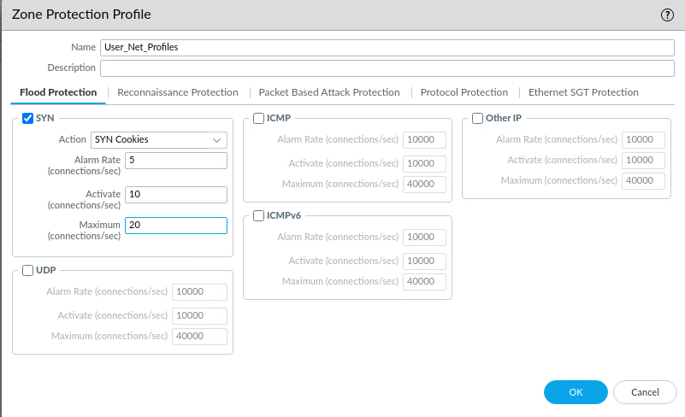
2. Click Network>Zones. Click Users_net. In the Zone window, select ‘User_Net_Profiles under the zone protection profile list. Make sure enable packet buffer protection is checked. Click OK.
3. Commit your changes. Minimize the web interface and open the EDU-210 folder.
4. Double click SYN Flood, press enter when prompted twice. Reopen the web interface.
5. Head to Monitor>Logs>Threat. Click the X button. There should be entries for TCP Flood in logs.

# Reconnaissance Protection

Will be modifying the existing protection profile in order to include protection against port scans and ping sweeps. Attackers will often use these techniques against hosts to determine open ports, version of services running on the open ports, or host OS. A Zone protection profile can detect and block packet-based attacks, including use of specific IP header options like Record Route attacks. Firewalls can be configured to detect/drop IP packets with certain header options. Zone protection profile will be updated to include traceroute protection and test zone protection profile by generating traceroute traffic.

1. Head to Network>Network profiles>Zone protection. Click User_Net_Profiles. Select the reconnaissance protection. Change the TCP port scan like below. Commit your changes.

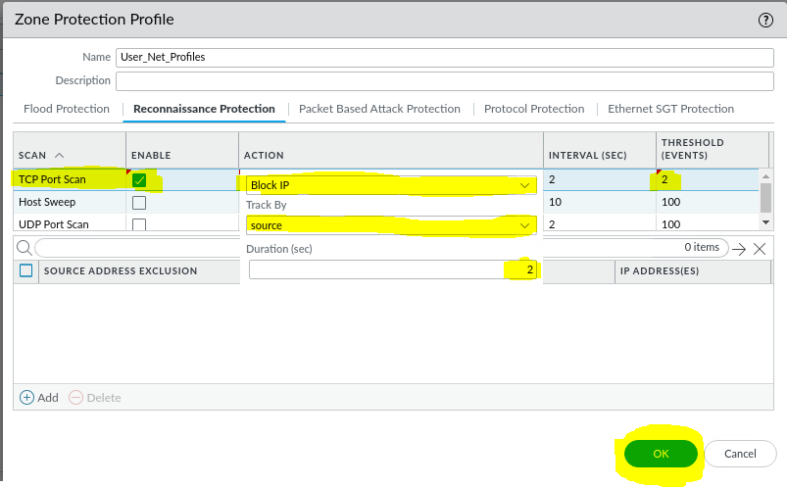

1. Minimize the web browser and open the edu-210 folder again.
2. Double click TCP Scan and press enter. Press CTRL+C after 30 seconds to stop the script.
3. Open the web interface and head to Monitor>Logs>Threat. There should be several SCAN: TCP Port scan records showing. If not, wait 30 seconds and refresh the logs.
4. Head to Network>Network profiles>Zone protection. Click User_Net_Profiles.
5. Click ‘Packet Based Attack Protection’ tab. You may need to click the IP drop tab, select Record route option on the IP option drop panel. Commit your changes.
6. Minimize your web page, and open edu-210 folder. Double click IP Record Route Ping. Press enter twice. The script should stall with 100% packet loss.

# Concurrent Sessions on a target host and DOS protection

You will be running a scrip that uses nmap to open multiple concurrent sessions from client host in the user_net zone to the target server in the Extranet zone. The script tests whether the firewall can allow 10 concurrent sessions to target host. You will use concurrent connections script again in order to generate multiple concurrent sessions to linux host in the dmz zone. You will use the same script again to generate multiple sessions to the target server In the Extranet zone.

1. Go to your User_net_profile and remove the zone protection profile. Commit changes.
2. Open the 210 folder and double click Clear Firewall Logs. Press enter twice. Verify the logs have been removed from the web interface log.
3. Run the concurrent connections script for about 3 minutes then CTRL+C.
4. Head to monitor>logs>traffic. Clear any filters. Head to monitor>logs>threat. Notice there are no logs present.
5. Head to Objects>Security>Profiles>Dos protection. Click Add and configure as shown below. Click OK

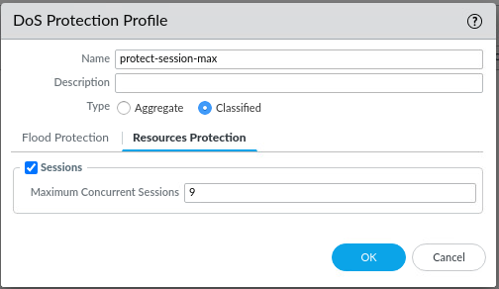

1. Head to Policies>DOS protection and click Add with the name Internal-protection. Select users_net for source zone, Extranet for destination zone, protect for action, check classified, protect-session-max for profile, and destination-ip-only for address. Click ok. Verify that the information looks correct. Click commit.
2. Minimize the browser and open the edu-210 folder. Run Concurrent sessions for 3 minutes before stopping the script.
3. Head to monitor>logs>threat. Notice the new threats.
4. Head to objects>security profiles>dos protection. Click protect-session-max. Deselect sessions from the resources protection tab.
5. Head to network>network profiles>zone protection>user_net_profiles. On the flood protection tab configure as follows.

|  |  |
| --- | --- |
| **Parameter** | **Value** |
| **SYN** | **Verify** **the** **check** **box** **is** **selected** |
| **Action** | **SYN** **Cookies** |
| **Alarm** **Rate** | **1000** |
| **Activate** | **1100** |
| **Maximum** | **1300** |

1. Click reconnaissance protection. For tcp port scan, deselect the enable checkbox. Click OK.
2. Head to network > zones. Click Users_net. From the zone window select user_net_profiles for the zone protection profile. Click OK.
3. Head to objects>security profiles>dos protection. Click protect-session-max. In the DOS protection profile window, configure like below. Click OK when done.

|  |  |
| --- | --- |
| **Flood** **Protection** tab | **Verify** **that** **the** **tab** **is** **selected** |
| **SYN** **Flood** | **Select** **check** **box** |
| **Action** | **SYN** **Cookies** |
| **Alarm** **Rate** | **5** |
| **Activate** **Rate** | **10** |
| **Max** **Rate** | **20** |

1. Commit your changes. Open the edu-210 folder then run concurrent connections once again for about 3 minutes.
2. Open the web interface again and head to monitor>logs>threats. Notice new threats.
3. You are finished!

# Troubleshooting/Verification

1. Be sure to double check and look at the logs. If you are not seeing the correct logs in your web interface, go back and try the previous step again.
2. Make sure you wait long enough for the scripts to finish where they are marked. It will say in the instructions if you need to wait for the script or not.
3. Make sure you load the lab 6 snapshot at the beginning of the lab.

# URL Filtering

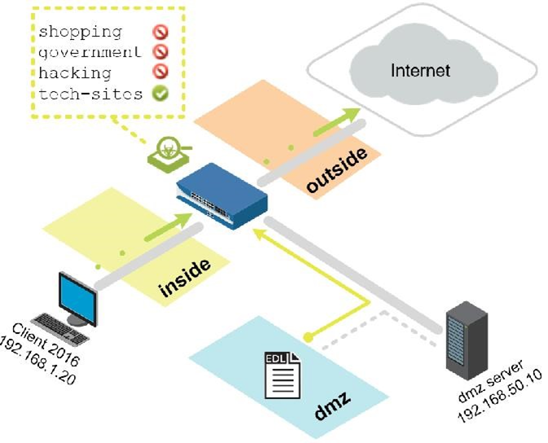

|  |  |  |  |
| --- | --- | --- | --- |
| **Virtual Machine** | **IP Address** | **Account**  (if needed) | **Password**  (if needed) |
| **Client** | 192.168.1.20 | **lab-user** | **Pal0Alt0!** |
| **Firewall** | 192.168.1.254 | **admin** | **Pal0Alt0!** |

# Create a security policy rule with a custom url category

Use a custom url category object to create a custom list of URLs and use it in the URL filtering profile/ as match criteria in Security policy rules. In a custom URL category, you can add URL entries individually/import a text file that contains a list of URLS.

1. Head to objects>custom objects>url category. Click add.
2. Enter the following information:

|  |  |
| --- | --- |
| **Parameter** | **Value** |
| Name | Type **news-sites** |
| Description | Type **Blocked news sites** |
| Sites | Click **Add** and type the following news sites:  **foxnews.com bbc.com msnbc.com**  **\*.foxnews.com**  **\*.bbc.com**  **\*.msnbc.com** |

1. Create a new security policy that uses our custom URL category to block new sites configured in the category object. Add new policy and configure as shown:

|  |  |
| --- | --- |
| **Parameter** | **Value** |
| Name | Custom blocking policy |
| Source zone | Inside |
| Destination zone | Outside |
| Application | any |
| URL category | News-Sites |
| Action | Reset both client and server |

1. Click OK and commit your changes. Verify that you can reach a website
2. Verify that your policy blocked access to cnn, bbc, or foxnews.
3. Open a terminal emulator and enter “nslookup ‘url’”*url is the news site you tried to open*
4. See that DNS for CNN.com returns a 151.101.x.x range or 1.1.1.1. Go to Monitor>logs>traffic and find a 1.1.1.1 entry.

## Troubleshooting/Verification

1. Try browsing to blocked/allowed sites. If you are getting a different result than expected, go back and double check your policies/URL categories.
2. Check your logs and double check you are seeing what you expected. Refresh if nothing is showing up
3. Make sure your policy is not being overshadowed by another.
4. Try verifying dns is functioning by doing an nslookup/dig in your terminal emulator.

Blocking threats with App-ID

Derek Iszczyszyn

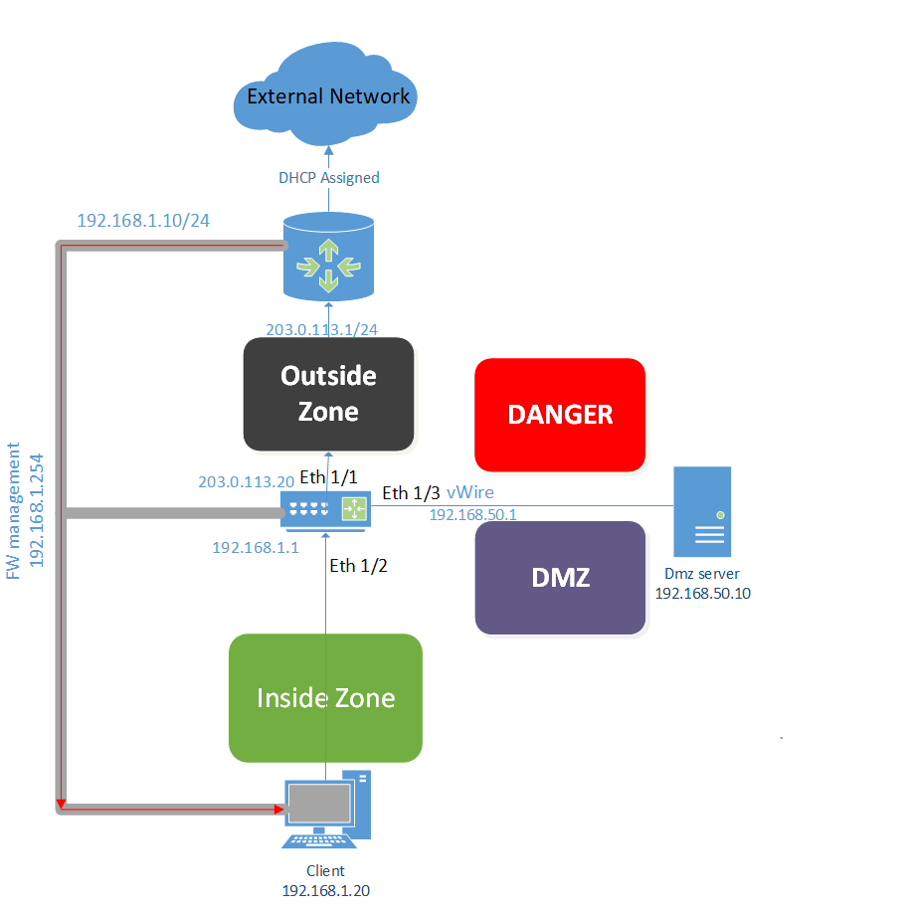

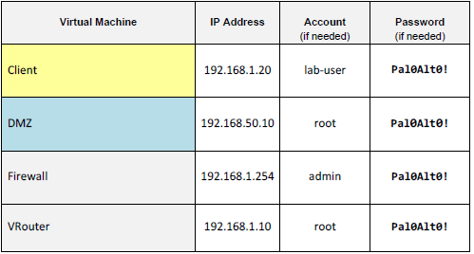

## Applying baseline config to the Firewall

1. Load onto your Palo Alto web interface and login with Admin/Pal0Alt0!
2. Load snapshot edu-210-lab-08.xml and click OK. Commit your changes once the snapshot finishes loading. Click close.

## Creating an FTP service object and Port-based security policy rule

You will be creating an FTP service object that defines the FTP port. After that, you will create and test a port-based security policy rule that will enable you to simulate part of the process of migrating from a legacy port-based security system to a next-gen app-based security policy. You will also generate ftp traffic from client host->FTP server in the extranet zone. You will examine the traffic log to see how the firewall processed the FTP traffic.

1. Head to Objects>Services. Click add and set the name as service-ftp, protocol as TCP, and destination port as ‘21’. Click OK.
2. Head to Policies >Security. Click add. Under general, type migrated-ftp-port-based for name. For description, ‘Migrated from legacy firewall’
3. Click source, Users_net for source zone and any for source address.
4. Click destination, Extranet for the source zone, and any for the destination address.
5. Make sure the application tab is set to any. Click on Service/URL category and add service-ftp. Click the actions tab and verify the action is set to allow/Log at session end for log settings.
6. Verify the newly created policy is visible in the list.
7. Use your mouse to drag and drop the new rule to just above the Users_to_extranet rule.
8. Click commit, then click close. Minimize your browser and open a terminal emulator.
9. Enter the command below to connect to the ftp server at 192.168.50.21.

C:\home\lab-user\Desktop\Lab-Files> **ftp 192.168.50.21 <Enter>**

1. Login with username ‘paloalto42’ and password ‘Pal0Alt0!’. Type bye at the prompt.
2. Close the terminal window by typing in exit. Reopen the firewall page.
3. Head to monitor>logs>traffic. Create and apply the filter ( addr.src in 192.168.1.20 ) and ( app eq ftp ) into the filter builder.
4. Minimize your web browser once again.

## Generate Application Traffic

You will be running a short script that generates app traffic from the client workstation to hosts against the internet and extranet security zones.

1. Open the class-scripts folder, edu-210 folder, then double click ‘App Generator’.
2. Press enter to start the script. Allow the script to finish. Once it finishes, press enter and allow 30 seconds to a minute to complete before proceeding.
3. Reopen your palo alto web page. Head to monitor>logs>traffic. Create and apply the following filter. ( addr.src in 192.168.1.20 ). Apply it. Note the entries in the app column.

## Configuring an App Group

You will configure an app group that includes some palo alto networks applications. These apps are used to label and control access to the content update network and other palo alto networks products and features. You will be adding the app grp to a security policy rule.

1. Head to objects>app groups. Click add.
2. In the App group window, config the following.





1. Click OK.

## Configure a security policy to allow update traffic

You will create a specific security policy rule to enable access to Palo Alto Networks content updates. This configuration is an example of the positive enforcement model where you config what the firewall should allow rather than only specifying the blocked traffic.

1. Head to Policies > security. Click add. Configure the following.

Name: Allow-PANW-Apps Description: Allows PANW apps for firewall

Source zone: Users_net Source Address : 192.168.1.254

Destination zone : Internet Destination address : Any

Applications : paloalto-apps Service/URL : any

Action: allow Log settings: Log at session end

1. Click OK. Verify the new rule is listed just above **intrazone-default**, and commit your changes.

## Test the Allow-PANW-Apps security policy rule

1. Head to device>dynamic updates. Click ‘Check now’ in the bottom left.
2. Select monitor>Logs>traffic. Clear any filters that exist. Create and apply a new filter. ( app eq paloalto-updates ).

## Examine tasks lists to see shadowed message

The firewall provides notifications when there is a rule shadowing one or more rules. The Rule Shadow tab appears at the end of the commit process. You will use the task list to examine your earlier commit, incase you do not notice the rule shadow tab.

1. In the bottom right, click the tasks button. Scroll down and locate the most recent entry for commit. Click the link for commit.
2. In the job status-commit window, select the rule shadow tab. This interface shows you what rule shadows which. Click the number under the count. Click close.
3. Click close in the task manager window.

## Modify the security policy to function properly

You will modify your security policy to ensure that only the Allow-PANW-Apps rule allows Palo Alto networks content update traffic. This config is another example of the positive enforcement model where you config what the firewall should allow, rather than only specifying what needs to be blocked. You will also modify the rule that allows traffic from Users_net to the internet. Instead of allowing any app, the rule will allow only a few apps now.

1. Head to policies>security. Click users_to_internet to edit the rule. Click the app tab and config the following.





1. Commit your changes and click close.

## Test the modified security policy rule

You will test the modified security policy to verify that it is working as intended. You want to verify the dynamic update traffic from the firewall uses the Allow-PANW-Apps rule.

1. Head to Device>Dynamic Updates. Click Check now.
2. Select Monitor > logs> traffic. Apply the following filter. ( app eq paloalto-updates ) in the filter builder. Look for log entries for the app ‘paloalto-updates’ It should be the allow-PANW-apps rule.
3. Open a new tab and type [www.paloaltonetworks.com](http://www.paloaltonetworks.com) in the address bar and press enter. Once you have verified the page can open, close the tab.
4. Select monitor>logs>traffic. Clear any filter that is in place. Create and apply the new filter ( addr.src eq 192.168.1.20 ) and ( rule eq Users_to_Internet ) in the filter builder.

## Troubleshooting/Verification

1. Make sure you have the correct values entered.
2. Be sure that you have your correct source and destination zones/addresses for each policy.
3. Double check that your policies are not being shadowed by others.
4. Ensure you wait for the script to finish running before checking your log traffic.

Security Policy

Derek Iszczyszyn

You will be setting up two sites to test out sec policies for access to apps and services on the internet and to a dmz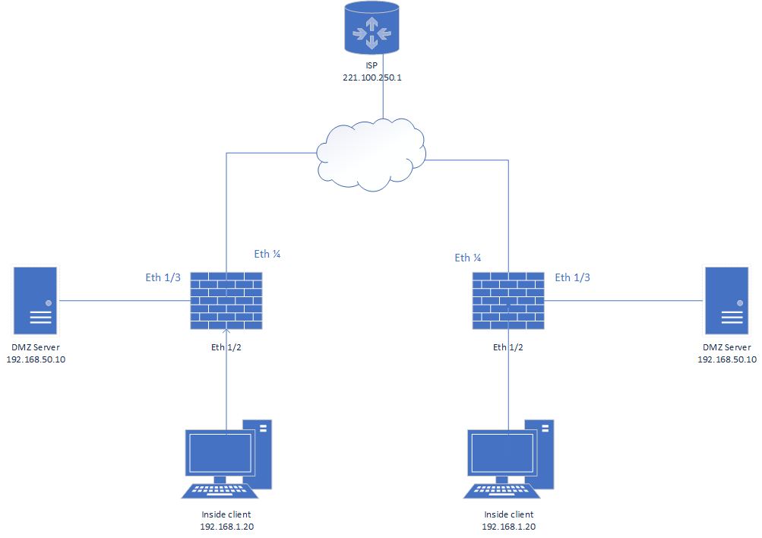

|  |  |
| --- | --- |
| **Device/Int** | **Address** |
| Site 1 Eth1/4 (outside) | DHCP assigned on 221.100.250.0 /24 net |
| Site 1 Eth 1/2 (inside) | 192.168.1.1 /24 |
| Site 1 Management | 192.168.1.254 |
| Site 1 Eth 1/3 (dmz) | 192.168.50.1 /24 |
| Site 1 Inside Client | 192.168.1.20 /24 |
| Site 1 DMZ Server | 192.168.50.10 /24 |
| Site 2 Eth1/4 (outside) | DHCP assigned on 221.100.250.0 /24 net |
| Site 2 Eth 1/2 (inside) | 192.168.1.1 /24 |
| Site 2 Management | 192.168.1.254 |
| Site 2 Eth 1/3 (dmz) | 192.168.50.1 /24 |
| Site 2 Inside Client | 192.168.1.20 /24 |
| Site 2 DMZ Server | 192.168.50.10 /24 |

|  |  |
| --- | --- |
| Device Name Interface | Address |
| Inside Clients | Site 1 = 192.168.1.20 /24  Site 2 = 192.168.1.20 |
| Eth 1/2 users_net | Site 1 = 192.168.1.1 /24  Site 2 = 192.168.1.1 /24 |
| Management Addresses | Site 1 = 192.168.1.254  Site 2 = 192.168.1.254 |
| Eth 1/4 outside | DHCP Assigned in the 221.100.250.0 /24 network |
| Eth 1/3 DMZ | 192.168.50.1/24 |
| DMZ Server | 192.168.50.10 |

## Setting up

1. Schedule two pods on the same Dell Node in the VPN lab ***IMPORTANT***
2. Do the following to Site 1
3. Load named config 5 / commit
4. Delete the V-R
5. Create a new V-R and give it a name
6. Add Eth ½ and Eth1/3 to the new V-R
7. Config the following on Eth ¼ (Your new internet interface)
8. Make it a layer3 interface
9. Assign it to the new V-R
10. Assign it to a new zone, called outside
11. Config its IP for DHCP Client
12. Config source NAT (PAT) for Users_Net to outside
13. Config a Sec Policy for Users_Net to outside
14. Add default route to the V-R for 0.0.0.0/0 to the ISP of 221.100.250.1 using interface eth ¼
15. Rename the extranet zone to ‘DMZ’
16. Commit your changes and test that you can access the internet.
17. If everything worked, repeat the steps for site 2
18. You are now going to set up your DMZ server at site 2 so that site 1 (and everyone else if you were on enterprise edge) has access. You will lock it down so that the outside world can only open web pages. Configure the following on site 2.
    1. Set up a destination NAT policy that maps traffic from the outside zone to the dmz zone and maps the outside addr of 221.100.250.x to 192.168.50.10.(x comes from subsituting a “1” for the “7” in pod number.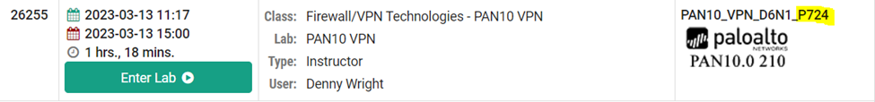
    2. The 724 highlighted above would become 124 in the 4th octet or 221.100.250.124. In the example above, the address is mapped to 192.168.50.10 with a destination (static) NAT policy.
    3. Create a sec policy for traffic going from outside to the DMZ. Allow only web-browsing.
    4. Commit your changes.
19. Now go to Site 1, and try to browse to the 221.100.250.x address on site 2’s DMZ, config’d above. It should work. Try going to a terminal and pinging the addr, it should fail.
20. Now that your dmz is locked down on site 2, you want to lock down your users at site 1 to ensure that they do not access apps on the internet that they shouldn’t be accessing. Lock them down to web browsing and DNS to lookup names.
21. On site 1, configure the Sec policy for internet access with the following:
    1. Under application section, add SSL and web browsing
    2. Add a new security policy for DNS. Configure your source and destination zones to be users_net and outside. Commit your changes.
    3. Try to browse to NPR.org. Now try to open google.com.
    4. Google, and many other sites have an app signature ( remember App-ID). For this to work, you have to add google-base as an Application, in addition to ssl/webbrwsing.
    5. Try accessing google.com now. You need to add facebook app as well.
    6. Lets assume that you want to limit your users to web browsing any site, but they can only use https service. You would do the following:
       1. Keep DNS policy
       2. Remove the applications to remove app-ID inspection
       3. Add the following services in service tab:
       4. Commit and test google, facebook, and other sites.

## Troubleshooting/Verification

1. Test that you are able to browse to various websites using your new security policy. If something is not working, go back and double check all of your policies.
2. Be sure you have the correct parameters in your destination NAT that maps your DMZ addr to the outside world. Very important to have the zone correct otherwise it will not work.
3. Be sure you are attempting to connect to the translated address with an ‘http’, not ‘https’ as our policy does not allow the use of https yet at that step.
4. If you are having troubles comparing your values and entered parameters, undock both sites from netlab and have them side by side to compare.

# Palo Alto VPN

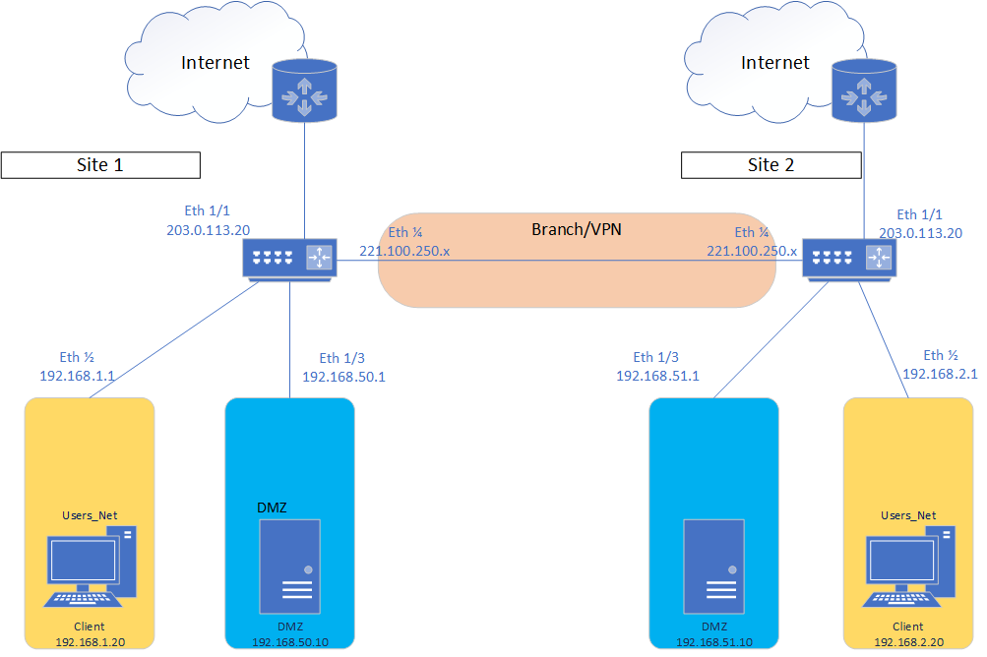

|  |  |
| --- | --- |
| Device Name Interface | Address |
| Inside Client | Site 1 = 192.168.1.20 /24  Site 2 = 192.168.2.20 /24 |
| Palo Alto Ethernet 1/2 inside | Site 1 = 192.168.1.1 /24  Site 2 = 192.168.2.1 /24 |
| Palo Alto Ethernet 1/1 outside | 203.0.113.20 /24 |
| Palo Alto Ethernet 1/4 branch | 221.100.250.x /24 where x = last 2 digits of Pod number |
| VPN Tunnel Address | Site 1 = 172.16.0.1 /24  Site 2 = 172.16.0.2 /24 |

## Setting up

1. Schedule two labs in the same node on netlab. Make sure you use the vpn class.
2. Connect to your palo alto web GUI on site 2 using the mgmt addr of 192.168.1.254
3. Load named config for lab 5
4. Change eth1/2 ip addr to 192.168.2.1/24 and remove 192.168.1.1/24. Update the mgmt profile in the eth1/2 interface under the advanced tab to ‘allow-ping’.
5. Update your mgmt addr as follows. Device>Interfaces>Management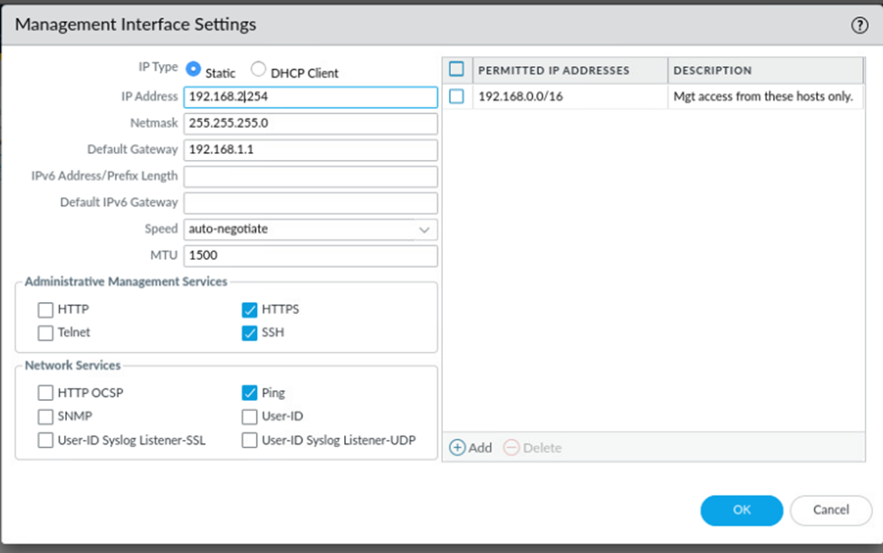
6. Note the Permitted IP addresses on the right allows the 192.168.2.20 host still. If you wanted to lock this down more to allow only one host to manage, add the entry here.
7. Commit your changes. You will lost connection to site 2 temporarily.
8. *IMPORTANT* Change your IP on your client. You will also need to change all of your alias addresses to the 192.168.2.x network using nano to update your etc file. Note there are 4 alias addresses you need to change.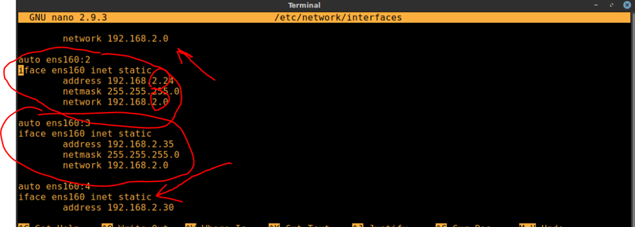
9. Reconnect to site 2’s management interface.
10. Ensure you are able to reconnect to 192.168.2.254 for firewall mgmt.
11. Your sites are set up with the base addresses for the lab now
12. Go to site 1 and lo into the Firewall on your browser from the client.
13. Be sure to load named config lab 5 for site 1.
14. We will use eth ¼ interface to connect our firewalls together. Note: We are using the network 221.100.250.x/24 as the network that the pods share together, for each address we will use the last two digits of the pod number to choose the value of the last octet. If the pod were p739, the address would be 221.100.250.39. You will create the Branch zone (layer3) before configuring the interface and add the interface to that zone when you config it.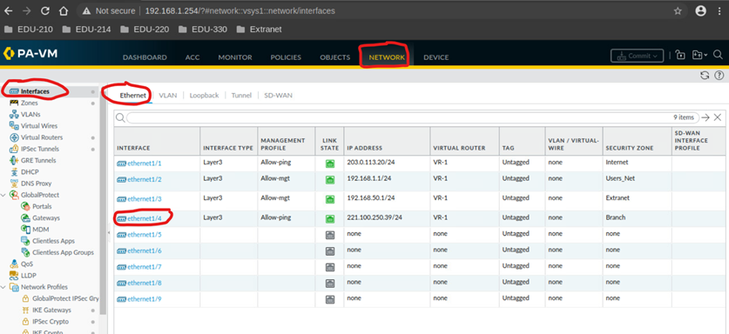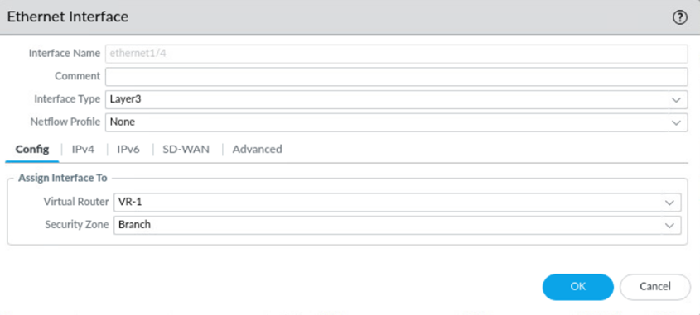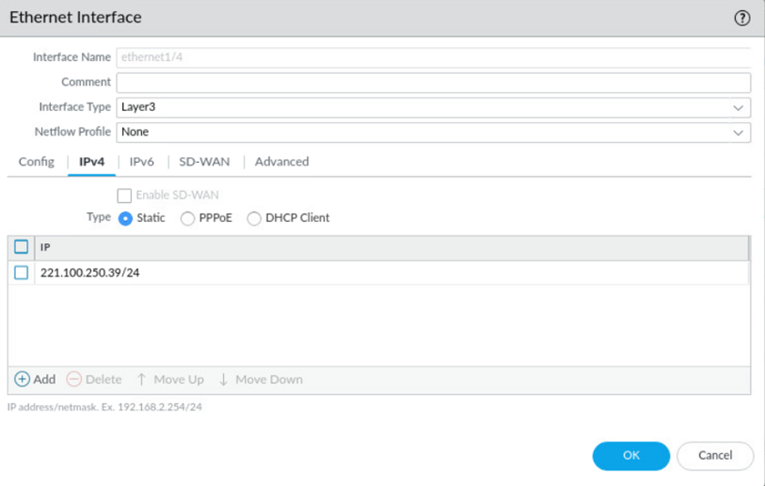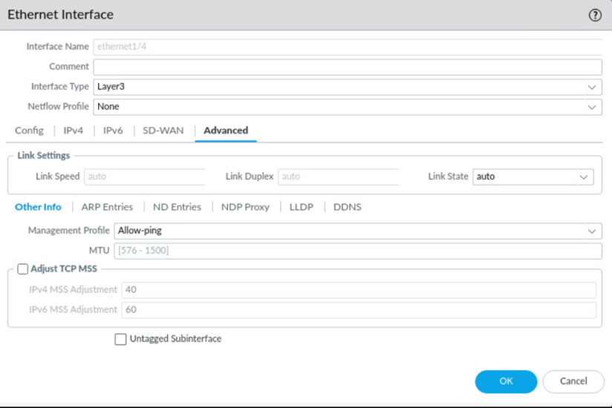
15. Go to network>interface>tunnel, click add and assign the following:
16. Name: Tunnel.1
17. Virtual Router: (select the VR you would like the tunnel int to reside)
18. Security zone:(config new zone for the tunnel called VPN. This will give us more control.)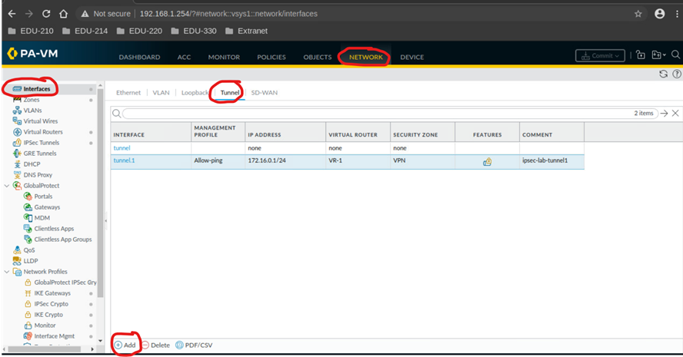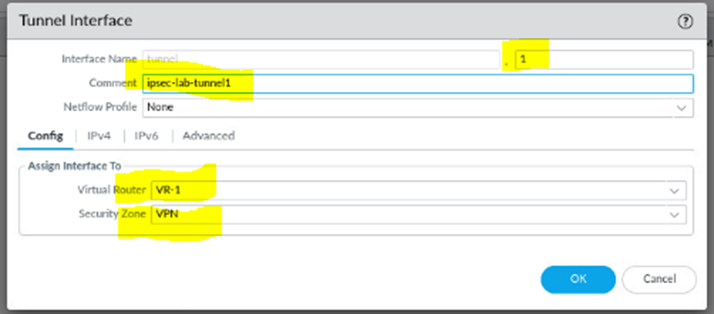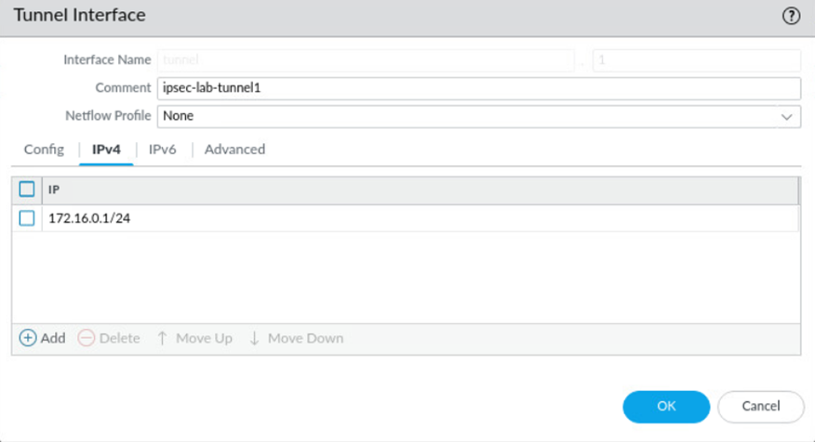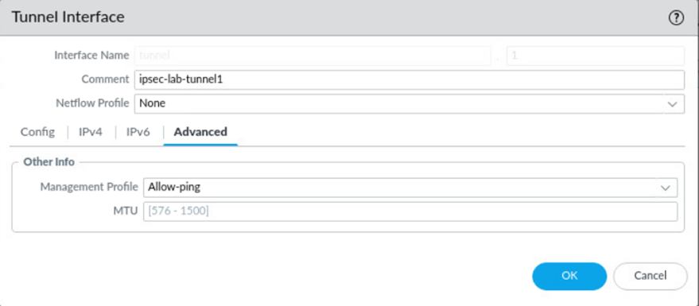
19. Note: If the tunnel interface is in a differet zone from the zone where the traffic will originate/depart, then a policy is require to allow the traffic to flow from src zone to the zone containing the tunnel int. This is the case for us, and we will config the appropriate sec policies later
20. Configuring an ip-addr on the tunnel int is optional. One needs an IP-addr if you intend to run dynamic routing protocols over the tunnel int or static routes. We need to set up a static route in the tunnel later. Use 172.6.0.1/24 on Site 1 and 172.6.0.2/24 on site 2.
21. Go to network>network profiles>IKE Crypto. Click add and define the following parameters:
22. Name: Does not matter, you will refer to it later though
23. These parameters need to match the remote firewall for the IKE Phase-1 negotiation to be successful.
24. 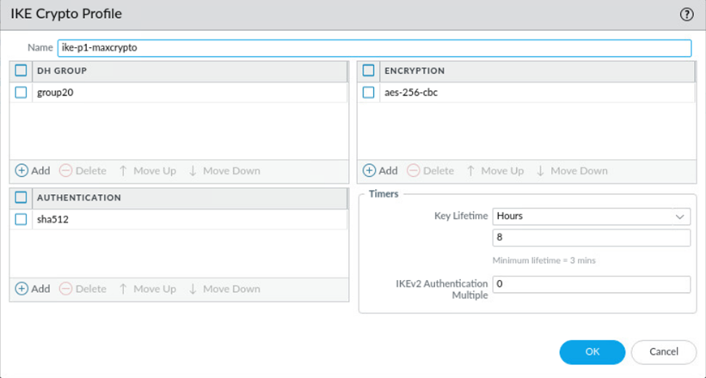
25. Go to network>network profiles>IKE Gateway to configure the IKE Phase-1 gateway. Note that this is where we use the IKE Crypto profile created above.
26. The name can be anything, take note of it as it will be used in a later step
27. There are options for the Version where you can select IKEv1 only mode, IKEv2 only mode or IKEv2 preferred mode.
28. Version: Select the IKE version that the gateway supports and agrees to use with the peer gateway. IKEv2 preferred mode causes the gateway to negotiate for IKEv2, if the peer also supports IKEv2, that is what they will use. Otherwise, the gateway falls back to IKEv1. **USE IKEv2 only.**
29. Interface: The interface that leads towards the other firewall(eth ¼). This is usually the internet facing interface.
30. Preshared key: Use Password01
31. Local/Peer identification: Defines format and identification of the local/peer gateway, which are used with the preshared key for IKEv1 phase 1 SA and IKEv2 SA establishment
32. Choose one of the following types and enter the value: FQDN(hostname), IP addr, KEYID(binary format ID string in HEX), or user FQDN(email addr). If the value is not specified, the gateway will use local/peer IP addr as the local/peer identification value.
33. 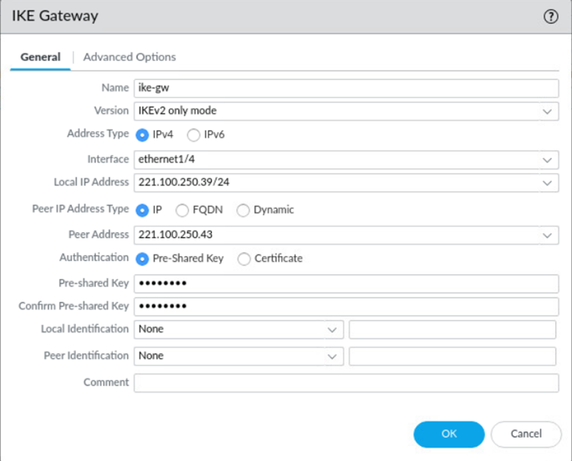
34. 
35. IKE Crypto profile was the name you gave your IKE Crypto profile in previous steps****
36. Under networ>Network profiles>IPSec crypto, click add, define the IPSec crypto profile to specify protocols and algorithms for identifications, authentication and encryption in VPN tunnels based on IPSec SA negotiation(IKE Phase 2)\
37. The parameters should match the remote firewall for the IKE phase 2 negotiation to be successful
38. 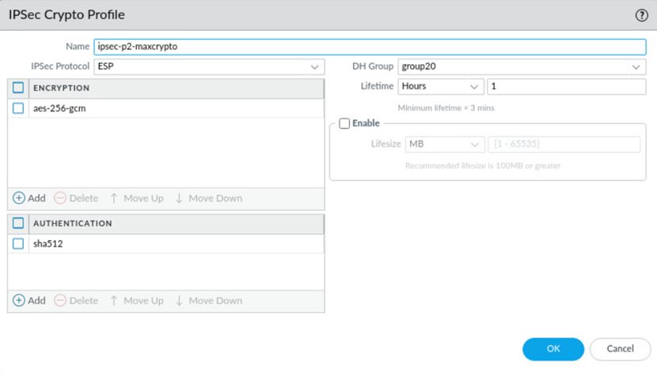use cbc instead of gcm as shown in the picture.
39. Note the name you give, as it will be used In the next step
40. Network>IPSec tunnels, click add. In the general window, use the tunnel interface, IKE gateway, and IPSec crypto profile from above to establish IPSEc VPN tunnels between the firewalls.
41. *** IKE Gateway and IPSec crypto profile names are the names from previous steps***
42. If the other side of the tunnel is a peer that supports policy based VPN, you need to define the proxy IDs. When configuring an IPSec tunnel proxy-ID config, to indentify local and remote IP networks for traffic that is NAT’d, the proxy-ID config for the IPSec tunnel must be config’d with the Post-NAT IP network info, since the Proxy-ID info defines the netwrks that will be alowed through the tunnel on boths sides for the IPSec configuartion. We need to config the local and remote networks in the Proxy-ID at each site. For site 1, config as shown:
43. 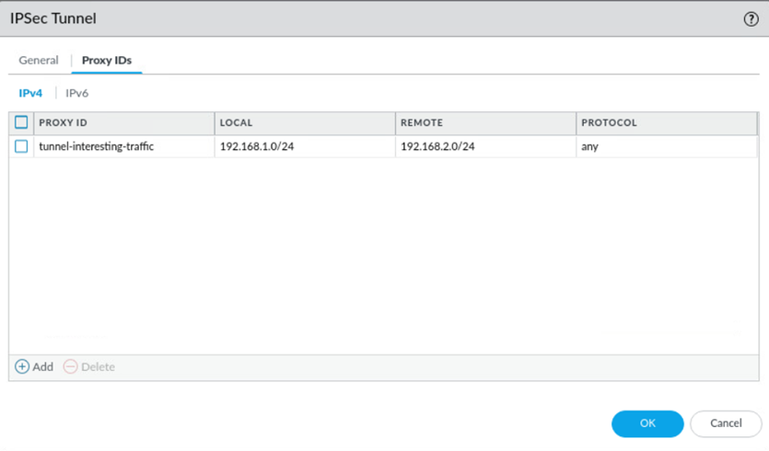
44. You need to configure a static route on Site 1 for the remote 192.168.2.0/24 network, so the firewall knows where to route this traffic. Route the traffic to the next hop in the tunnel of site 2 (172.16.0.2. Note above we config’d the tunnel addr on site 1 as 172.16.0.1)
45. Network>Virtual routers, click on you VR profile(should be VR-1), then click static routes.
46. Add a new route for the network that is behind the other VPN endpoint. Use the correct tunnel interface.
47. Click OK when done.
48. 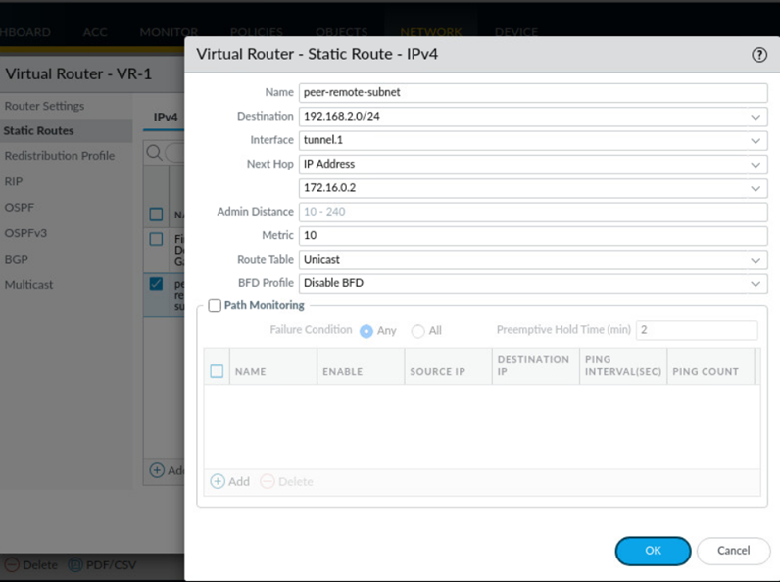
49. Config the required security policies. Allow IKE negotiation and ipsec/esp packets. By default, ike negotiation and ipsec/esp packets should be allowed via intrazone. This is due to the IKe negotiations coming from the outside (branch zone, though it is often the zone that faces the internet as mentioned earlier) and negotiate with the outside interface.
50. While IKE and IPSec negotiations are allowed by default by the intrazone-policy(see that policy on your device to confirm why) you should limit the IKE negotiations and IPsec to a specfic outside host. Also, note that for traffic to pass between the VPN zone and Users_Net zone, you must set up a policy for traffic in both ways. Config three sec policies similar to the ones below:
51. 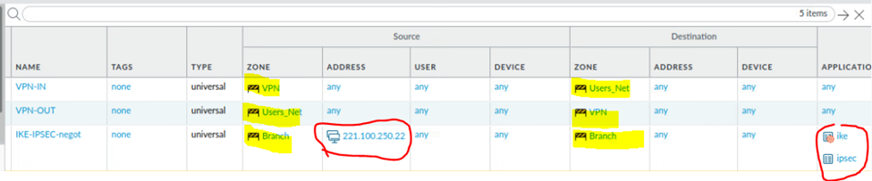
52. Note the allow-tunnel-traffic-in(out) policies above are required for functionality. Traffic will move in the tunnel between Users_Net and VPN zones, requiring policies. Otherwise, the traffic will be dnied by the interzone-default policy. Commit the config.
53. Make the corresponding config on the Site 2 firewall. Note that some values would be changed since the other firewall should treat local and remote addrs in a similar manner, though local and remote addrs, static routes, tunnel addrs, eth1/4 addrs, allowed addrs I nthe IKE-IPSec policy, etc will change
54. Test by pinging from the PC Client on Site 1 to the Client on Site .

## Troubleshooting/Verification

1. Verify the tunnel is functioning properly by pinging the Site 2 client from Site 1.
2. Undock both sites and compare them side by side if that makes it easier to compare values.
3. Make sure all of your authentication, encryption and etc protocols are the same. In one of the pictures, it shows to use aes-256-gem instead of cbc, and that is incorrect. They all need to be the exact same in order to function properly.
4. Try pinging Site 2 from site 1. This will be the 172.16.0.2 address.

# Blocking threats using custom apps

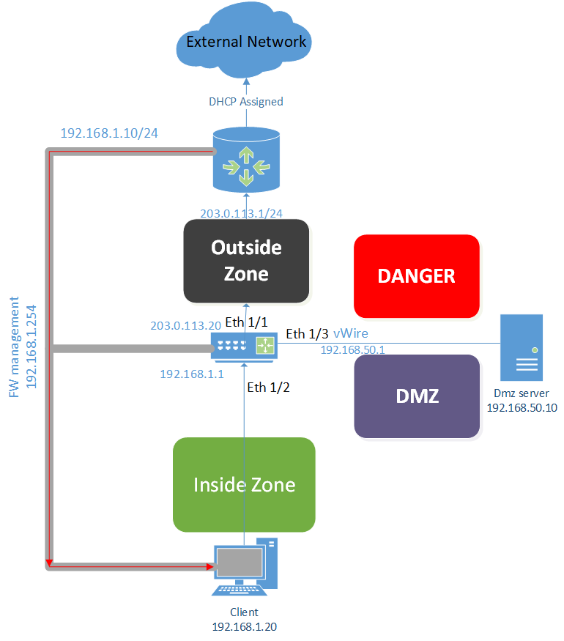

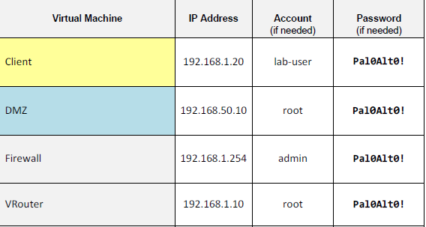

## Gather custom Application information

You will gather info about the traffic that this app uses so you can create a custom application signature

1. Open your palo alto web GUI, load named config for lab 10 and commit your changes.
2. Open the class-scripts folder on your client desktop, open the edu-210 folder, and double click Custom-App-1. Press enter and allow the script to complete, enter again.
3. Open the web gui back open and head to monitor>logs>traffic. Create and apply the new filter ( addr.dst eq 192.168.50.22 ). Write down the Source IP, Destination IP, port number, and IP protocol. If protocl is not displayed, place your mouse over any column header and select columns>IP Protocol.

## Configure a packet capture

You will configure a packet capture on the firewalls data plane. The goal of the packet capture is to identify a unique bit pattern that’s used to create a custom app signature.

1. Monitor>Packet capture. Click clear all settings. Click yes, then click OK in the PCAP window.
2. In the configure filtering window, click manage filters
3. Click add under the packet capture window.
4. Configure the following in the packet capture stage window:
5. 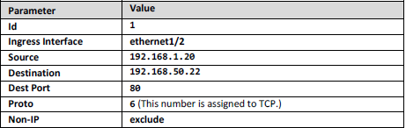
6. Toggle the filtering button to ON.
7. Under the section for configure capturing, click add to config a file for the receive stage on the firewall.
8. In the packet capture stage window: Stage = receive File = receive-file.pcap. Click OK.

## Packet Capture App Traffic

You will take a packet capture on the firewall using the custom app on the client host.

1. Ensure you are in monitor>packet capture. Toggle packet capture ON.
2. Click OK in the packet capture warning window.
3. Minimize your browser, open the edu-210 folder, double click Custom-App-1.
4. Press enter and allow the script to finish. Press enter once finished. Reopen web GUI.
5. Toggle packet capture to OFF. Refresh the web GUI to view the receive-file listed in the captured files panel. Click it to open it in wireshark.

## Analyzing the packet capture

1. In wireshark, find and highlight the first entry for GET
2. 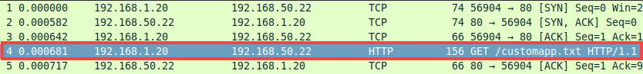
3. In wireshark, click hypertext tranfser protocol to expand the display, notice the HTTP request header included a GET /custom-app.txt entry and the host 192.168.50.22
4. Close wireshark. Click clear all settings under Monitor>Packet capture. Click yes and OK.
5. In ‘Captured Files’, delete receive-file.pcap. Click Yes.

## Create a custom Application with a Signature

You will use the info discovered in the packet capture to create a unique signature that can identify HTTP traffic to the internal company custom application

1. Select objects>applications. Click add. Configure the following:
2. 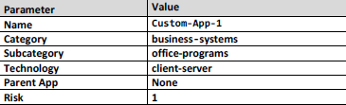
3. 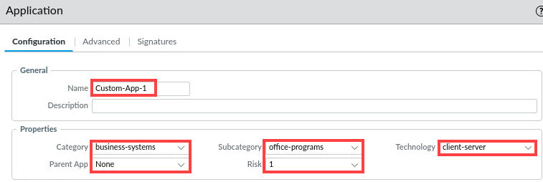
4. Click the advanced tab, select port, click add and type tcp/80.
5. Click the signatures tab and select add. For signature name, Signature-1. Scope: Transaction. Leave ordered condition match selected and click add. Configure the following:
6. 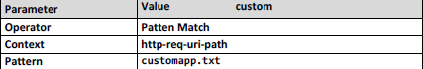
7. 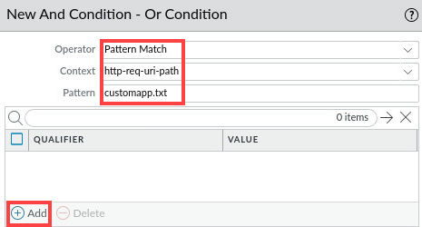
8. In the qualifier window, ‘http-method’ for Qualifier and ‘GET’ for value. Click OK three times to close out the application window.
9. To display only custom apps, select custom applications on the filter dropdown menu. A new entry for custom-app-1 appears at the top.

## Add the custom application to the Sec Policy

You will create a security policy that allows hosts in Users_net to access the custom app in the Extranet zone.

1. Policies>Security. Click Add. Name = ‘Allow_Custom_App’ Description = ‘Allows users to access custom application in the extranet zone’. Select users_net for source zone, and extranet for destination zone. Add ‘Custom-App-1' under the application tab. Verify allow Is selected for the actions tab.
2. Highlight the Allow_Custom_App rule and move it just above ‘Users_to_Extranet’.
3. Commit youur changes. Click close and move on to the next task.

## Testing the custom Application

You will run the custom app to determine if the firewall correctly identified the traffic

1. Open the edu-210 folder on your client machine and double click the custom-app-1 icon. Run the script and hit enter when it finishes. Reopen your internet GUI.
2. Head to monitor>logs>traffic. Create and apply a new rule ( addr.dst eq 192.168.50.22 ) in the filter builder. Note the application label is custom-app-1 and how the custom app enables more granular logging of app traffic. The traffic was not identified as web-browsing any longer.

## Troubleshooting/Verification

1. Make sure your custom rule is not being shadowed by others.
2. Check your logs and verify whether the traffic is being identified as expected.
3. Go back and verify your traffic is being sent/received to/from the correct zones.

# Blocking threats with User-ID



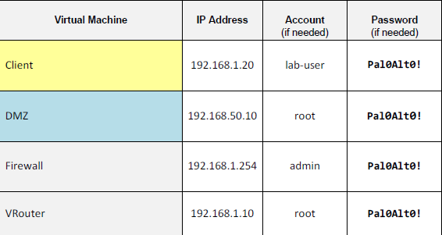

## Examine Firewall Configuration

You will review the settings that another admin has configured for Application groups/Sec policies

1. Log into the Palo Alto web GUI, and load saved config lab 11 and commit your changes once loaded. Head to policies>security. Click the allow-all-acquisition policy.
2. Click through all of the tabs and make note of the zones and default config.
3. Clear the counters for all sec policy rules and hit yes in the reset window:
4. 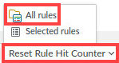
5. Objects>Applications groups and note the two new app groups. Minimize the webpage.

## Generate traffic from acquisition zone

You will config a packet capture on the firewall’s data plae. The goal of the packet capture is to identify a unique biy pattern to be used to create a custom app signature.

1. On your client desktop, open Remmina. Double click the ‘Server-Extranet'
2. In the CLI, enter ‘ cd /home/paloalto42/pcaps92019/app.pcaps’ hit enter.
3. Enter ‘./Appgenerator-2.sh’ verify the script is running. Reopen your web GUI.
4. Select monitor>logs>traffic. Clear any filter. Note that almost all traffic is hitting Allow-All-Acquisition Rule. Allow 3-6 mins for the traffic logs to update.
5. Add **Source User** column if necessary, by clicking the dropdown on source.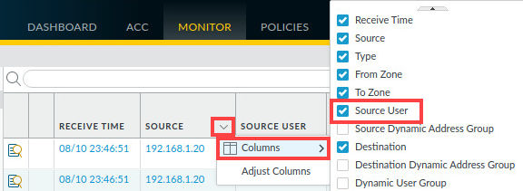
6. Drag/Drop Source user column between Receive Time and Source columns.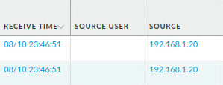

## Enable User-ID on the Acquisition Zone

You will enable User-ID on the acquisition sec zone as part of the process of enabling User-ID on the firewall.

1. Network>Zones. Click acquisition to open the zone.
2. Select **Enable User Identification** in the zone window. Click OK.

## Modifying Allow-All-Acquisition Zone

You will change the set of apps that acquisition users are allowed to access by modding the existing rule

1. Policies>Security. Open the Allow-All-Acquisition rule. Type in the following under general.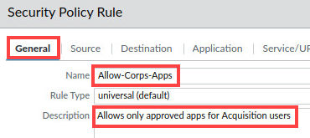
2. Select the app tab and config the following. Click OK when finished.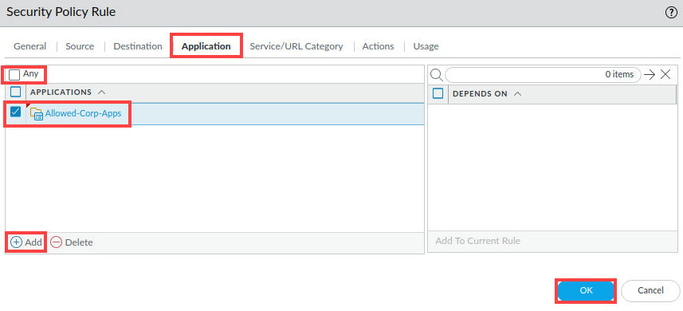

## Create Marketing Apps rule

You will create a new sec policy rule to allow only marketing users to access the allowed-mktg-applications.

1. Add a new security policy, and configure the following: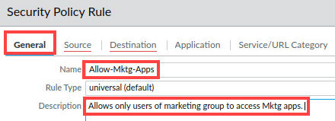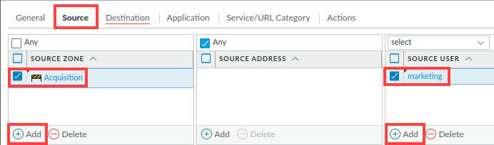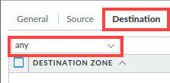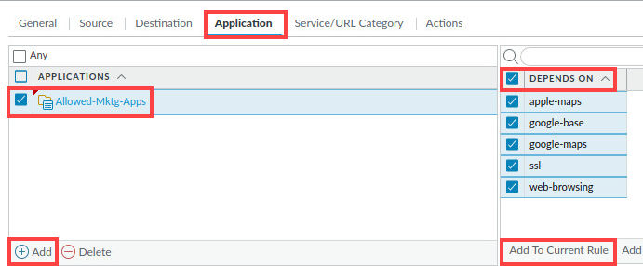
2. Be sure to clickAdd to Current Rule. Note the applications have been added to the window.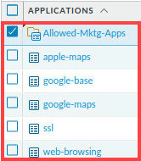
3. Verify the actions tab is set to allow. Click OK.

## Create Deny Rule

You will create a sec policy that allows hosts in Users_Net to access the custom app in Extranet zone.

1. Create a new security policy. Configure as shown: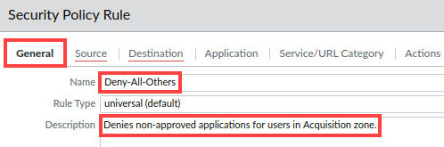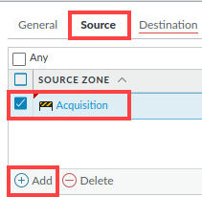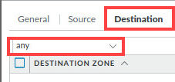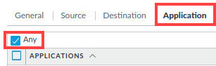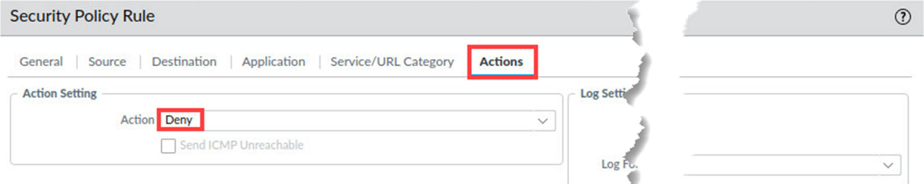
2. Click OK once you set up the rule. Verify that deny-all-others is at the bottom of the policies.
3. Commit your changes. Click OK and close once the commit finishes.

## Generate traffic from the acquisition zone

You will generate traffic from the acq zone using the Extranet-Server

1. Open the remmina application. Ensure you are still in the app.pcaps directory and run the Appgenerator-2.sh script. Close the server-extranet connection once the script finishes running.
2. Reopen your web GUI

## Examine User-ID logs

You can see info about user-ID through the firewall CLI or in the web GUI. You will use both to examine User-ID entries.

1. Head to Monitor>logs>User-ID. The firewall should have numerous entries with username-to-ip-address mappings. If the User mappings are not showing, repeat the task above.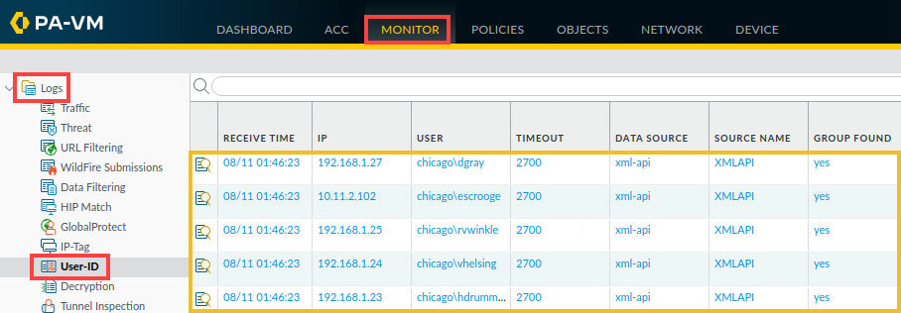
2. Minmize the web GUI and reopen the Remmina app. Double click Firewall-A. Click OK.
3. Enter ‘show user ip-user-mapping all’. Close the firewall-a window. Reopen the web gui.

## Examine Firewall Traffic Log

Create and apply filters for viewing rules and users

1. Head to monitor>logs>traffic. Type ( app eq youtube-base ) in the filter builder, and apply the fitler.
2. Clear the filter, and type ( app eq dns ) apply the filter.
3. Clear the filter, and type ( app eq facebook-base) apply the filter.
4. Type ( app eq facebook-base ) and ( action eq allow ) apply the filter.
5. Clear the filter and type ( app eq instagram-base ) and ( user.src eq ‘chicago\bbart’ ). Apply

## Troubleshooting/Verification

1. If the expected traffic is not showing up, try rerunning the scripts and allowing a few minutes before viewing the traffic logs. *they take a bit to complete!*
2. Make sure you loaded the named configuration before starting the lab
3. Make sure your policies are not being shadowed by others

# Blocking unknown malware with Wildfire





## Create a WildFire Analysis profile

You will create a wildfire analysis sec profile that you can attach to Sec policies to test files/URLs for malware.

1. Open your web GUI, and load named config lab 12. Commit your changes.
2. Head to objects>Security profiles>wildfire analysis. Click add. Configure the following: 
3. Click add and configure the following. Click ok once finished: 

## Apply wildfire profile to security rules

You will apply the wildfire analysis profile to a security policy

1. Policies>Security. Click on Users_to_internet rule. Select the actions tab, and select profiles under profile settings. Select Corp-WF for wildfire analysis. Click OK.

## Updating wildfire settings

You will update the wildfire settings

1. Select device>setup>wildfire. Click the gear icon to edit general settings.
2. Check the boxes for **Report benign files** and **report grayware files**. Leave the remaining unchanged and click OK.
3. Commit your changes and click OK.

## Testing wildfire analysis profile

1. Open a new tab in your client browser. Type ‘http://wildfire.paloaltonetworks.com/publicapi/test/pe’ press enter.* This site generates an attack file with a unique signature that simulates a zero-day attack. *
2. Verify the wildfire-test-pe-file.exe downloaded at the bottom of your window.
3. Close the new tab you opened and minimize your client browser. Open remmina.
4. Double click firewall-A, click OK, and type ‘debug wildfire upload-log show’ and hit enter * The command should display the output log: 0, filename: wildfiretest-pe-file.exe processed…. This output verifies that the file was uploaded to the WildFire public cloud. The message might take a minute or two to display.*  
5. Type exit to close the SSH session to the firewall. Reopen your web GUI page.

## Examining wildfire analysis details

You will examine wildfire analysis details in palo alto networks firewall and view a pdf of the detailed log view

1. Monitor>logs>Wildfire submissions. Verify wildfire-test-pe-file.exe is visible. * do not continue to the next step if the file is not showing up, this can take 5-15 minutes for wildfire to process and return a submission *
2. Click the magnifying glass next to the entry in order to open the detailed log view. 
3. In the detailed log view window, under general, note the **Verdict**.
4. Click the tab ‘Wildfire Analysis Report’ at the top of the window.
5. In the wildfire analysis summary window, click **Download PDF**.
6. Scroll through the report and view the detailed info about the wildfire analysis of the file.

## Troubleshooting/Verification

1. Verify the file is being identified by wildfire analysis in your traffic logs before continuing.
2. Make sure you have loaded your named snapshot config for lab 12.
3. If your web GUI is not loading, be patient with it. It can take a while at times to start, especially when first loading the lab

# Blocking threats in encrypted traffic





## Testing firewall behavior without decryption

You will test the firewall behavior without decryption by downloading a virus

1. Open your palo alto web GUI, sign in, and load saved named config lab 13. Commit.
2. Type [**http://192.168.50.80/eicar.com**](http://192.168.50.80/eicar.com)and press enter. It should be blocked.
3. In another tab, type [**www.eicar.org**](http://www.eicar.org). Press enter.
4. Click the link for **Download Anti Malware Testfile**
5. Scroll down and find the download section. Right click the link for **eicar.com** file and select **save link as**. Save to the downloads directory. * notice the download is not blocked because the connection is encrypted, and the virus is hidden. *
6. Close the two new tabs you opened.

## Creating a self-signed cert for trusted connections

You will generate a certificate on the firewall that will be used for clients connecting to https websites that have certs issued by trusted Cas (cert authorities). The firewall will use this cert as part of the decryption process between clients>trusted https websites.

1. Device>Certificate management>Certificates. Click generate to create a new CA cert.
2. In the generate certificate window, config the following:  
3. Click OK. You should have a new entry in the device certificates table. Click trusted-cert.
4. In the certificate information window, click the box for forward trust certificate. Click ok* This action instructs the firewall to use this certificate to decrypt traffic between clients and trusted HTTPS sites.*

## Creating a self-signed cert for untrusted connections

You will generate a cert on the firewall that will be used when clients connect to HTTPs websites that DO NOT have certs issued by trusted CAs - *example* sites that use self-signed certs or certs that have expired. Firewall uses this cert as part of the decryption process between clients > untrusted https websites.

1. Click generate to create a new CA certificate. Config the following and click generate: 
2. You should have a new entry in the device certificates table. Click untrusted-cert.
3. Check the box for Forward untrust Certificate. Click OK.

## Create decryption policy for outbound traffic

You will create a decryption policy to decrypt HTTPs traffic from the users_net security zone to the internet security zone.

1. Policies>decryption. Click Add. Configure as shown:   
2. Verify that service is set to any and the box above url category is any.* Note that the Any setting for URL category instructs the firewall to decrypt all HTTPS traffic, regardless of the type of website users are accessing. Decrypting traffic from users to website categories such as Health and Medicine, Shopping or Government can expose Personally Identifiable Information (PII). In a production environment, you will need to make sure you only decrypt traffic which is appropriate.*
3. Click the options tab and config as shown: 
4. Verify the new policy is visible, and the config matches as shown: 
5. Commit your changes. Click OKAY when finished committing.

## Test outbound decryption policy

You will test the new policy

1. Open the firefox browser on your client desktop.
2. Type [**https://eicar.org**](https://eicar.org)and press enter. The browser should show a warning page. Click advanced. Click the link for ‘View Certificate’. *note the issuer name section for [www.eicar.org](http://www.eicar.org) contains 192.168.1.1’ 
3. Minimize your firefox browser for now.

## Export firewall certificate

You will export the trusted cert from the firewall

1. Device>Certificate management>Certificates. Highlight but do not open trusted-cert.
2. At the bottom of the window, click export certificate.
3. Leave all settings unchanged. Click OK to export the trusted-cert certificate. Minimize your browser

## Import firewall certificate

You will import the trusted-cert certificate from the workstation to firefox web browser

1. Reopen your firefox browser. In the upper right, click the ‘hamburger’ icon and click preferences. Select privacy and security, scroll to the bottom of the screen and locate the certificates section. Click View Certificates.
2. Click the authorities tab. Click import. Click downloads, select cert_trusted-cert.crt and click open. Place checks in both boxes for Trust this CA. Click OK.
3. The firewall trusted-cert entry should appear in the list of certificate authorities. Click ok.

## Test outbound decryption policy again

You will test the policy once again, now that you have imported the trusted certificate

1. Open a new tab in firefox and type **https://eicar.org.** Click the link for the anti malware file.
2. Locate the download section, click the eicar.com link to download the file. You should now receive a warning page that attempted download was blocked due to it being a virus.

## Reviewing firewall logs

You will examine info in the firewall logs to see more details about the decryption process

1. On your palo alto web gui, head to monitor>logs>traffic. Type ( app eq youtube-base ). Apply
2. Add the decrypted column to the table by selecting the column dropdown menu.
3. Place the **Session end reason** column to the beginning of the table.
4. Type ( flags has proxy ) and ( session_end_reason eq threat ). Apply the filter. This should display the entries that have been decrypted from the client workstation, and that have been terminated due to a detected threat. Allow 1-2 mins if the traffic log is not showing.
5. Click the magnifying glass next to the entry to see more details.
6. You should see similar info indicating that the firewall detected the eicar.com file and used reset-server to terminate the session. Note several columns have been hidden in the lower section of the window. Close the detailed log view.
7. Head to monitor>logs>threat. Delete any filters in place. Note the entry for virus indicates that the firewall detected/blocked the eicar.com file

## Exclude URL categories from decryption

The decryption policy in place instructs the firewall to decrypt all traffic regardless of URL category. You will config a no-decrypt rule that tells the firewall to exclude sensitive categories of web traffic from decryption to avoid exposing PII (Personally identifiable information).

1. Select policies>decryption. Click Add. Configure the following:      
2. There should be two entries in the decryption policy. They should be out of order, with the decrypt user traffic shadowing the newly created policy. Drag and drop the new policy above ‘Decrypt_User_Traffic’. Commit your changes.* Always place no-decrypt rules at the beginning of the decryption policy table so that specified packets don’t get decrypted when the firewall evaluates rules from top-to-bottom.*

## Testing the no-decryption rule

You will test the new rule by browsing to a website that falls into one of the excluded categories

1. Open a firefox web browswer session. Type [**https://www.texas.gov**](https://www.texas.gov)and press enter
2. Click the padlock icon to view the site info window for Texas.gov. Click the next arrow to connection secure. Click more information. In the page info window, click view certificate. 
3. Note the issuer name is no longer 192.168.1.1* If the firewall had decrypted this website, the Issuer Name would be displayed as 192.168.1.1. Because you excluded government websites from Decryption, the firewall has not decrypted this site. The issuer name you see may be different from the example shown here.*

## Troubleshooting/Verification

1. Be sure to allow time for the traffic logs to populate before viewing them.
2. Be sure your old decryption policy is not shadowing the new one ( end of lab )
3. Make sure you type the correct parameters in the filter builder
4. *** for both labs *** be sure you have a high enough resolution. Some buttons / options will not load on your screen if your resolution is too low.

# Preventing use of stolen credentials

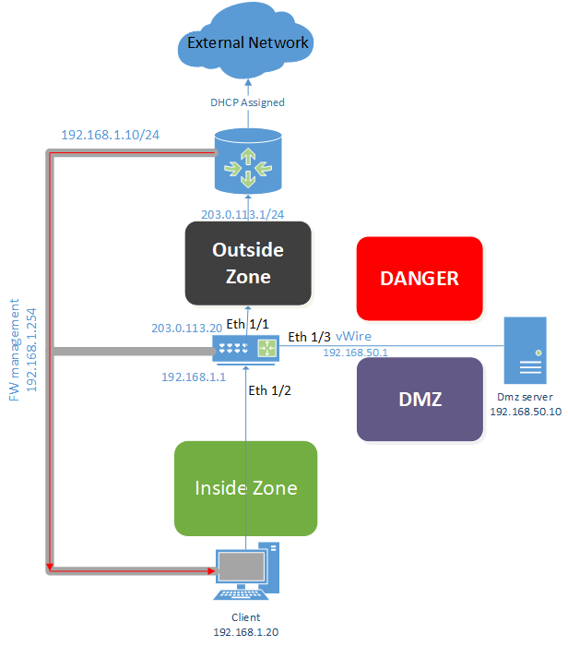

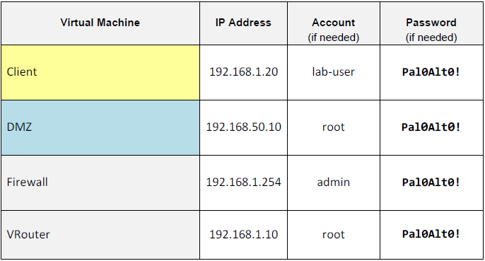

## Preparing the lab environment

You will continue from the config you completed in the previous lab on decrytpion. This will allow you to reconfig the certificate needed for the firewall and import it to Firefox browser. You will re-generate a cert on the firewall that will be used when clients connect to https sites that **DO NOT** have certs issued by trusted CA’s )sites that use self-signed certs of certs that are expired, for example). You will create a decryption policy to decrypt https traffic from users_net zone to the Internet zone. Remember certs are very important to help keep integrity between client>palo alto networks firewall. The firewall uses this cert as a part of the decryption process between clients>untrusted https sites.

1. Log onto your palo alto web gui, and load named snapshot for lab 14. Commit your changes.
2. Device>Certificate management>certificates. Click generate. Configure the following and click generate and ok.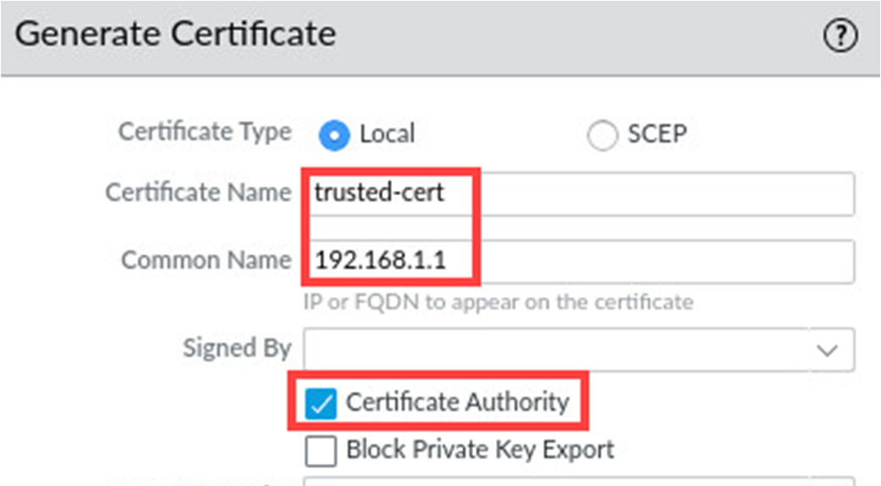
3. Click on trusted-cert in your device certificates table. Check the **Forward Trust Certificate** box and click ok. *this tells firewall to use this cert to decrypt traffic between clients>trusted https sites*
4. Click generate and configure as shown, click generate again then ok: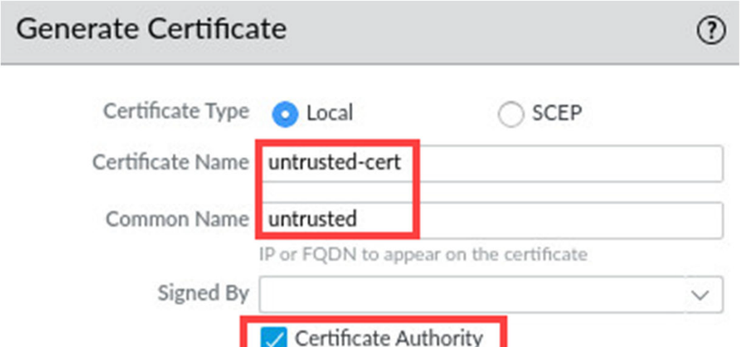
5. Click untrusted-cert in the certificate window, and check the **Forward UNTRUST certificate box** *be sure to click the untrust box, not the trust. This tells the firewall to use this cert to decrypt traffic between clients>untrusted https sites.
6. Device>Certificate Management>Certificates. **Highlight but DONT open trusted-cert.** Click export certificate at the bottom of the window. Leave all settings default and click OK.
7. Policies>Decryption. Click add. Configure as follows: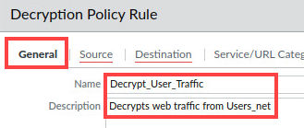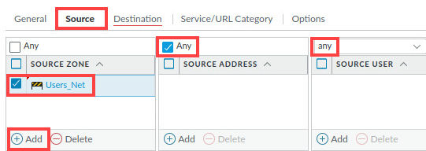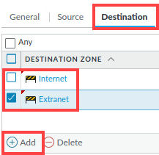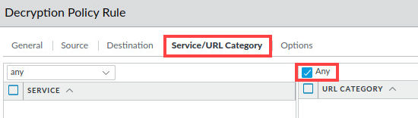* the Any settings for URL category tells the firewall to decrypt all HTTPS traffic, regardless of the type of site users are accessing. Decrypting traffic from users to site categories like health and medicine, shopping or government can expose PII (Personally identifiable information). In a production environment, you will NEED to make sure you only decrypt appropriate traffic. You will do this later in the lab like you did in the last*
8. Click the options tab and do the following: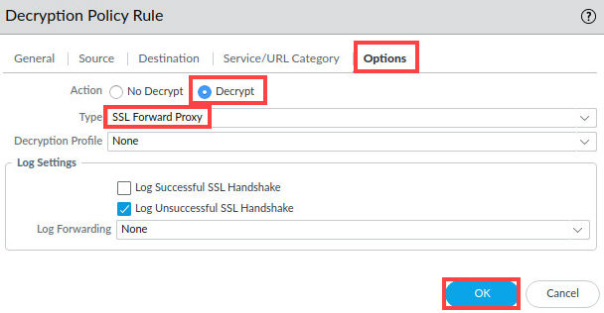
9. Verify the decryption policy is visible and the configuration matches as shown: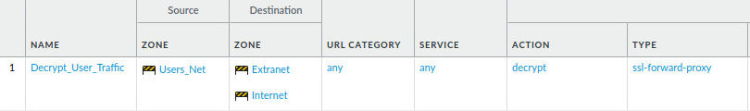
10. Minimize your web browser and open a firefox browser. Click the hamburger in the upper right and choose preferences. Select privacy and security. Scroll to the bottom and click view certificates. Click the authorities tab, and click import.
11. Click downloads, and select **cert_trusted-cert.crt** and click open. Place checks in both boxes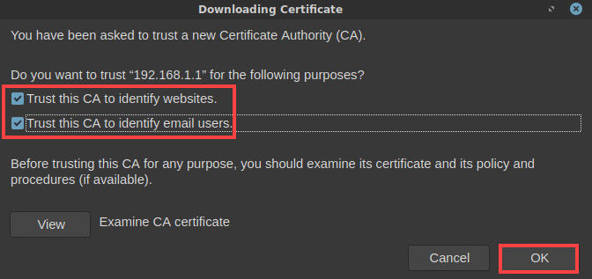
12. Click OK twice. *Firefox browser will trust any cert issued by the entities in this Authorities list. By adding the firewall cert to this list, firefox will trust any certs issued by the firewall. Note that the process of importing certs to client workstations varies based by browser type and OS.
13. Reopen your palo alto web gui and commit your changes.

## Test the firewall behavior w/o credential detection

You will connect to a website and enter a madeup user’s domain credentials. This allows you to see how the firewall behaves w/o credential detection configured.

1. Open a new tab and type [**https://login.paloaltonetworks.com**](https://login.paloaltonetworks.com)and hit enter. Click advanced and proceed to the unsafe tab.
2. For username, **sholmes**. For password, **1234**. Click sign in. You should get an error message. Close the tab.
3. Network>Zones. Click on Users_Net. Click **Enable user indentification** box. Click OK.
4. Objects>Security Profiles>URL Filtering. Click Corp-URL-Profile. Select User credential detection tab.
5. 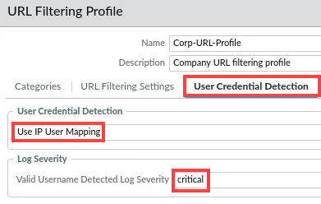
6. Select categories, and click on the follow by clicking the dropdown arrow on user credential submission:
7. 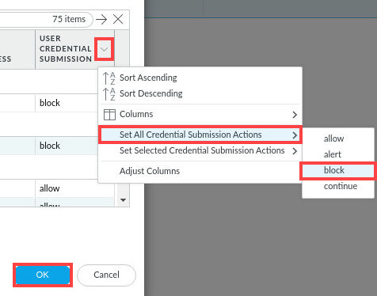
8. *Setting all URL categories to block credential submissions is NOT a good idea in a real environment because no users would be able to submit any credentials to any website. In this lab, you use this setting so you do not have to select individual categories and change the option.

## Apply the Corp-URL-Profile to Security policy

You will apply the corp profile to the security policy rule that allows user traffic>internet.

1. Policies>Security. Click users_to_internet. Click the actions tab and select Corp-URL-Profile as your url filtering profile. Commit your changes. Minimize your web browser.

## Provide the firewall with User-ID information

You will run a short script that generates application traffic from client workstation>hosts in the internet and extranet zones

1. Open the Class-scripts folder on your client desktop. Double click the user-id data script and allow it to run.
2. Reopen your web GUI, and head to Monitor>User-ID. You should see multiple entries showing the firewall has user-to-ip mappings.
3. Minimize your web browser.

## Provide the firewall with User-ID information

You will test the firewalls behavior wth credential detection

1. Open firefox web browser and head to [**https://login.paloaltonetworks.com**](https://login.paloaltonetworks.com)and press enter. Username= sholmes. The firewall should present you with a window stating that you have been blocked. *remember how before the firewall allowed you to submit a username, but now you cannot even do that with credential detection enabled. The firewall blocks the session when a username is submitted that belong to the domain*
2. Reopen your web GUI and head to monitor>URL Filtering. Add **Credential Detected** and **Decrypted** columns. Clear any filters in place.
3. Enter ( action eq block-url ). Press enter.*displays entries that were blocked*
4. Click the magnifying glass to learn more about this entry 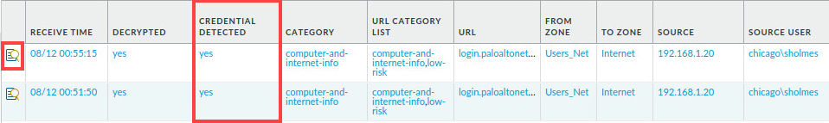
5. Scroll down and locate the flags section. Note the checkbox for Decrytped*indicates the firewall decrytped this traffic and was able to detected attempted credential submission.

## Troubleshooting/Verification

1. Be sure you commit your changes.
2. Be sure you checked ‘forward unstrust’ for the untrusted cert, and ‘forward trust’ for the trusted cert, I ran into this problem on my last lab***
3. Double check all of your policies match the ones shown in the lab.

# Implementing Day1 best practice configuration



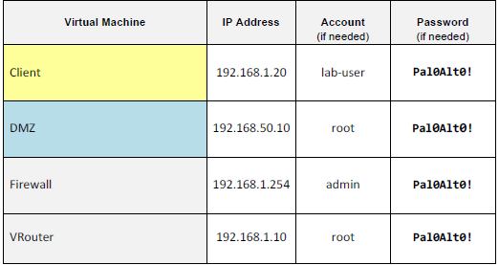

## Generate traffic w/o Security Profiles

You will create a new secrutiy policy and attempt to leave out the description. This lets you see what happens when an admin does not provide proper information when creating a policy.

1. Load named snapshot for lab 15 and commit your changes.
2. Open the remmina application on your client desktop.
3. Double click Server-Extranet. Enter **cd pcaps92019/attack.pcaps/**
4. Enter **./malwareattacks.sh** and allow about 6 minutes for the script to run uninterrupted. Open the firefox browser after.
5. Type [**http://192.168.50.80/badtarfile.tar**](http://192.168.50.80/badtarfile.tar)and hit enter. Select save file and click ok
6. Open a new tab and type [**http://192.168.50.80/companyssns.txt**](http://192.168.50.80/companyssns.txt)and hit enter. The browser displays a file with fake names and ssns. Close the firefox browser.
7. Open terminal emulator on your client. Type “dig @8.8.8.8 [www.quora.com](http://www.quora.com)”. *this returns a public IP, showing the URL is accessible.**quora.com is one of the entries in the malicious domains external dynamic list configured earlier**
8. Leave your terminal open and reopen your palo alto web gui.

## Modify existing security policies

You created security policies to inspect traffic for spyware and virus signatures. You created a security policy for wildfire that sends unknown exe files to Wildfire cloud for inspection, and created a URL filtering profile to prevent users from browsing to potentially dangerous categories of sites. You will be reviewing these profiles.

1. Objects>Security Profiles>Antivirus. Click Corp-AV. Configure the following: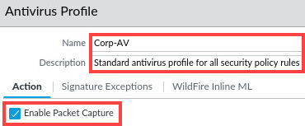*enabling packet capture tells the firewall to take very small packet captures that contain patterns in traffic that match the signatures used in the profile*
2. Objects>Security profiles>anti-spyware. Click outbound-as.
3. Change the name to Corp-AS and click the dns policies tab and configure as shown: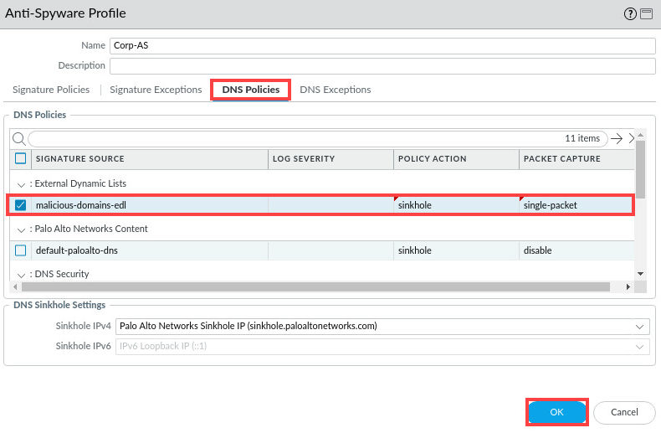

## Create a corporate vulnerability security profile

You will create a vulnerability security profile. Palo alto networks provides 2 vulnerability profiles that you can use as the basic for you own- strict and default.

1. Objects>Security Profiles>Vulnerability Protection. Check the strict box. Click clone. Click OK in the clone window.
2. Click the strict-1 entry. Change the name to **Corp-Vuln.** For description, **Standard vulnerability profile for all security policy rules**. Click OK.

## Create a corporate file blocking profile

You will configure a file blocking sec profile that the firewall uses to help detect, report and block attempts to download harmful filetypes. PA Networks provides 2 file blocking profiles as the basis for your own- basic file blockin and strict file blocking

1. Objects>Security Profiles>File blocking. Check the **strict file blocking** box. Click Clone and OK.
2. Click the strict file blocking-1 entry to open it. Change the name to Corp-FileBlock. For description, Standard file blocking profile for all security policy rules. Click OK.

## Create data filtering profiles

You will create a data filtering profile to detect and block the transfer of files that contain more than 3 USA ssns. Data filtering profiles are based on one or more data patterns, so you will need to configure a data pattern that matches variations of US social security numbers.

1. Objects>Custom objects>Data patterns. Click add. Configure the following: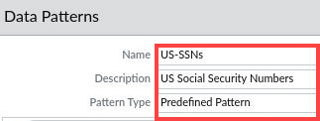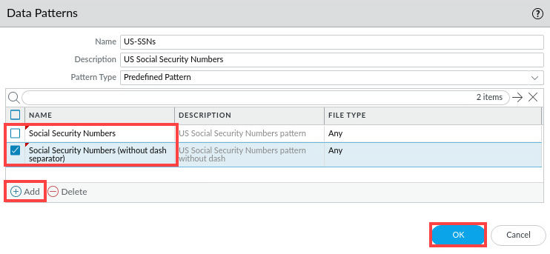
2. Objects>Security Profiles>Data filtering. Click Add. Configure: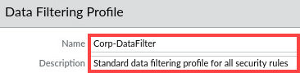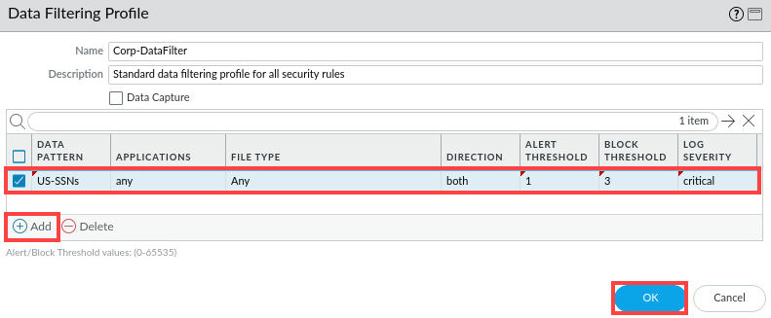

## Create a security profile group

To simplify the process of applying sec profiles to security policy rules, you can create security profile group that contains individual security profiles. You can apply the security profile group to a security policy rule, rather than selecting each profile for each rule. You will create a security profile group called Corp-Profiles-Group. Add each of your Corp-* security profiles to the group

1. Objects>Security profile groups. Click add. Configure the following: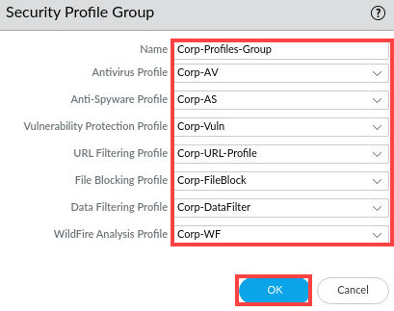

## Apply the Corp-Profiles-Group to a security policy

You will apply the new group to a security policy. With the security profiles in place, you can modify your sec policy rules to use these protections

1. Policies>Security
2. Edit each security policy rule that allows traffic and change the profile setting to use the corp-profiles-group. Make sure you edit each of the following rules: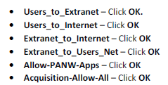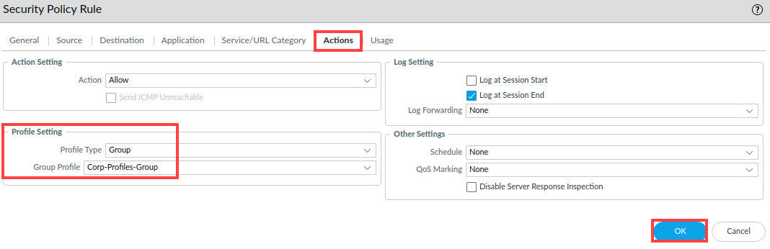
3. Verify each rules you modified is showing the new group profile by hovering over the profile icon for each rule.
4. Commit your changes and click OK.

## Generate attack traffic with security policies

1. Reopen the remmina application and type ‘cd pcaps92019/attack.pcap’ if you are not already in this directory. Run the ./malwareattacks.sh script and allow about 6 minutes for it to complete.
2. Reopen your firefox web browser and type ‘http://192.168.50.80/badtarfile.tar’ and hit enter.
3. You should now receive a ‘File Transfer Blocked’ page from the firewall.
4. Type ‘http://192.168.50.80/companyssns.txt’ and hit enter. You should now receive a data blocked page from the firewall *this is due to the data filtering profile and data pattern you defined for SSNS*
5. Close your firefox web browser and reopen the terminal emulator used earlier
6. Type ‘dig @8.8.8.8 [www.quora.com’](http://www.quora.com’) and hit enter.*note the DNS query is now in ‘sinkhole.paloaltonetworks.com’, this indicates that the firewall intercepted and sinkholed the DNS query using the DNS sinkholing function in the anti-spyware profile you made*
7. Reopen your web GUI and head to monitor>logs>threat. Clear and filters and hit enter. The threat log should contain various entries for ‘Spyware and vulnerabilities’.*These indicate that the firewall blocked malicious traffic using the vulnerability and anti-spyware profiles that you defined. BE SURE YOU LET THE SCRIPT FINISH BEFORE CHECKING, use the refresh button.*
8. Monitor>Log>URL Filtering*note numerous entries for blocked URLS**these indicate the firewall blcoked access to dangerous URL categories using the url filtering profile you made*

## Creating Tags/Applying to security policy rule

You can create color-coded labels to use in various places within the firewall web GUI. These can be visual aids that help you quickly locate information. You will be creating tags to use with your security policy rules. After the tags are defined, you can assign them to your security policies.

1. Objects>Tags. Click Add. Enter ‘Allow’ for the name, ‘Lime’ for the color, ‘Tag for allowed traffic’ for the comment. Click OK. Click add again.
2. ‘Block’ for the name, Red for the color, ‘Tag for blocked traffic’ for the comment
3. Policies>Security. Add the tags column if it is not already there.*drag and drop beside the name column.
4. In the row for Block-Known-Bad-IPs, click the link for **none** under the Tags column. In the tagging window select block from the dropdown box. Click OK.
5. Repeat this process for each remaining rule, applying Allow or Blocked, depending on the rules ACTION**
6. Your rules should match the following example: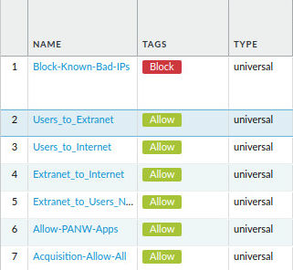
7. Commit your changes and click OK.

## Enforce rule tags and description requirements

You can force firewall admins to supply info in the description field of security policy rules and to apply a tag as well. This info can help you determine why a rule has been made and what it was made for.

1. Device>Setup>Management. Scroll down and click the gear for Policy Rulebase Settings.
2. Check the boxes for **Require Description on policies** and **Fail commit if policies have no tags or description.** Click OK.**you will need to modify NAT policy and assign a tag to each if you check Require tag on policies*
3. Commit your changes. You should see a message that one of your rules is missing a description. Click Close. Head to Policies>Security. Click the Acquisition-Allow-All rule to open it.
4. Give the rule a description, ‘Allows traffic from acquisition zone.’
5. Commit your changes. You should now see no error message in the commit window.

## Testing Rule Requirements

1. Head to policies>Security. Click add. Enter **Test-Policy** for name, click inside the description box and notice the new warning indicating that a description is required.

## Troubleshooting/Verification

1. If you are having a hard time finding entries in the security logs, try rerunning the script or refreshing your page. The script needs about 6 minutes in order to function properly.
2. Be sure you committed your changes before proceeding to the next step.
3. Verify you used the correct tags on the matching rules.